Hear

**Wilma Subra**

SCIENTIST & ACTIVIST

“***Environmental and Human Health Impacts of Methanol Plants”***

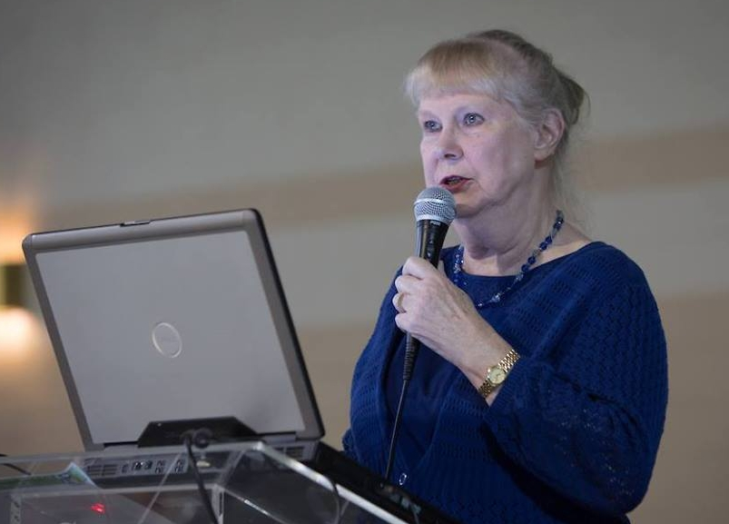

Subra, a [MacArthur Genius Award](https://www.macfound.org/fellows/625/) winner, has been fighting for decades to protect the interests of Louisiana residents who live in an area dubbed “[Cancer Alley](https://en.wikipedia.org/wiki/Cancer_Alley),” along the Mississippi River. Clusters of cancer patients have been diagnosed in the region, with many blaming the nearby industrial plants.

**Presentation and Q&A**

**Day/Date:** Thursday, Feb. 25 **Time:** 6:00 PM **Location:** University of Puget Sound, Kilworth Memorial Chapel

**Presented by**

**The Sierra Club, Pierce County and**

**The University of Puget Sound Sound**

**Policy Institute**

