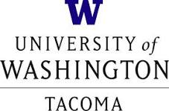
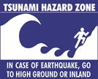
TESC 200 Environmental Seminar
Professor Dan Shugar
dshugar@uw.edu faculty.washington.edu/dshugar
253.692.4926
M 12.30-1.25 SCI309

Seminar Series “The Hazardous Northwest”

March 28 – First day: Intro to seminar series, and to SIAS Environmental Science faculty

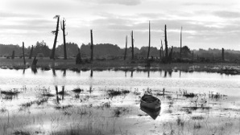
April 4 – Brian Atwater (USGS/UW Earth and Space Sciences): The Orphan Tsunami of 1700

April 11 – Ken Murphy (FEMA): Hazards from a FEMA perspective

April 18 – Tim Walsh (WA Department of Natural Resources): Washington’s Tsunami Hazard Mitigation Program

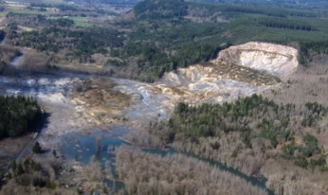
April 25 – Alison Duvall (UW Earth and Space Sciences): The “M9” project: reducing catastrophic effects of a Cascadia megathrust earthquake on social, built, and natural environments through the advancement of methodologies, early warnings, and community planning

May 2 – Simon Goring (University of Wisconsin Madison) EarthCube Distinguished Lecture: Fire, people, and connected data: How 21st Century approaches to the past can help tackle future challenges

May 9 – Scott Anderson (USGS): Downstream geomorphic response of the North Fork Stillaguamish River to the Oso Landslide

May 16 – Faisal Hossain (UW Civil and Environmental Engineering/UW Tacoma SIAS): Understanding the safety of water management infrastructures under the changing climate

May 23 – Evan Solomon (UW School of Oceanography): Evaluating the response of the Cascadia gas hydrate reservoir to contemporary ocean warming

Seminar series open to the public

