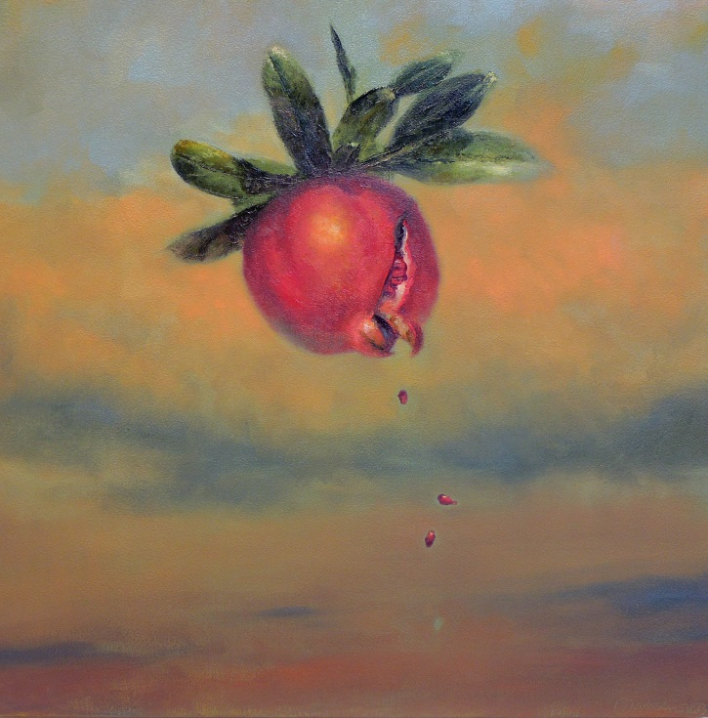
CONNECT TO YOUR INTUITION THROUGH PAINTING AND DRAWING

WORKSHOP WITH ARTIST MELISSA WEINMAN

I'm offering a workshop in my studio on Tuesday, May 7th, 10am-1pm. Come and join me for three hours of practicing the art of connecting to your intuition/spirit through creative play with painting and drawing. No experience or materials required. Everything provided. My studio is solvent free! (Oil, acrylic, and watercolor painting, charcoal, pencil and ink drawing, monotype printmaking will all be available for your use. Refreshments included.) $150 I look forward to guiding you through this wonderful opportunity to enjoy a no pressure, safe place to explore your inner artist. Take home your own frame-worthy artistic creation—a meaningful reminder of your own powerful intuitive resources.
I have 17 years of experience teaching university courses in painting, drawing, and the language of art. My work, which is based on images from my dreams, meditations, and visualizations, has been exhibited widely in galleries, universities, and museums. Visit www.melissaweinman.com for more information about my work and studio.
My studio is located just minutes from Point Defiance/Tahlequah Vashon ferry in Ruston/Tacoma and is easily accessible to I-5 via Ruston Way/Schuster Parkway/I-705.
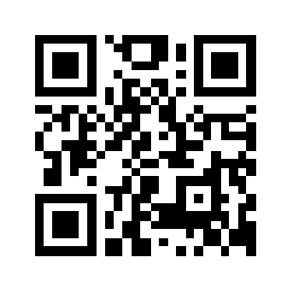
REGISTRATION
Please register by 5pm, Friday, May 3rd, to secure your spot! Call (253)709-3398 or email melissa.weinman@earthlink.net with your name, phone number, and email. I will confirm your registration and give you directions to my studio.

