###

for immediate release
July 31st 2013
Contact: Barb Clark, ATNW Tile Show Chair
206-940-5075, blclark007@gmail.com

Artisan Tile NW presents:
8th Annual Handmade Tile Show and Sale
October 4th2013, 3 pm to 8 pm
October 5th 2013, 10 am to 5 pm
Opening Reception: October 4th 2013, 6 pm to 8 pm
UW Center for Urban Horticulture
NHWS Hall, 3501 NE 41st Street, Seattle, WA 98195 (near U-Village, free parking)
Sponsored by Artisan Tile NW and UW Botanical Gardens
2013 Theme: Northwest Natives

Join us in celebrating Northwest Tile Artisans at the Center for Urban Horticulture in Seattle. This 8th annual Handmade Tile Festival will feature a juried show with tiles created with the theme Northwest Natives. Enjoy meeting the artists, tile making workshops, the tile sale and garden art.
Bring your antique and vintage tiles to this year’s tiles ‘antiques road-show’ event. The Northwest Society of Interior Design (NWSID) will present at this year’s tile festival again.
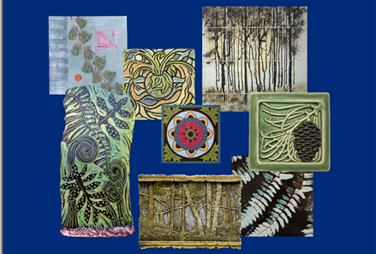
Artisan Tile NW advocates artistic excellence, innovation and awareness of handmade tile.
Artisan Tile NW is a non-profit Handmade Tile makers group, dedicated to the creation, promotion and preservation of the art and craft of handmade tiles. We sponsor a yearly show to raise public awareness about the range and diversity of artisan tiles being produced in the Northwest.

The Center for Urban Horticulture, founded in 1983, is now part of the University of Washington Botanic Gardens. It includes a 16-acre landscaped site with buildings and gardens, and the 74-acre Union Bay Natural Area, which provides publicly accessible wildlife habitat (more than 200 bird species have been sighted there) and an outdoor laboratory for UW research.

For additional information go to www.artisantilenw.org and http://depts.washington.edu/uwbg/visit/cuh.php

Sponsored by Artisan Tile NW and UW Botanical Gardens

###

