FOR IMMEDIATE RELEASE
Contact: Deborah Grady, Full Moon Art Gallery
(253) 858-8087 - deb@fmartgallery.com

Gig Harbor's First Saturday Art Walk – Voted one of top 5 Art Walks by Sunset Magazine!
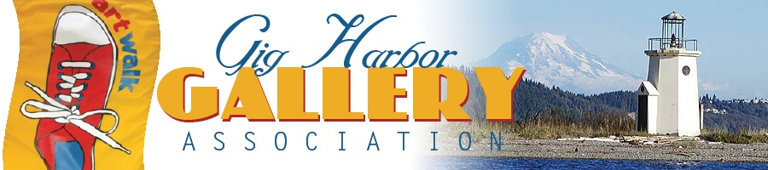

Each month the First Saturday Art Walk is held in the beautiful historic maritime community of Gig Harbor. October's Art Walk is Saturday, October 5th from 1:00pm to 5:00pm. Many of the following participating galleries will have on-site artist's demos.

Ebb Tide Gallery, 7809 Pioneer Way, Gig Harbor (253) 851- 5293
Featuring Kathy Thurston, an award winning wildlife artist specializing in the Gongbi Style, an ancient art form developed in China during the Han Dynasty.

Gallery Row, 3102 Harborview Drive, Gig Harbor (253) 851-6020
Featuring Artists Joan Teed, an Oil and Pastel Painter & Marjorie Mankin, who uses multiple mediums including Watercolor, Oil and Collage.

Kit Kuhn, A Jeweler Designed for You, 3104 Harborview Drive, Gig Harbor (253) 851-5546
Owner/Artist Kit features a wide variety of unique jewelry, mostly one of a kind or a limited series - designed for you!

Water’s Edge Gallery & Framery, Inc., 7808 Pioneer Way, G.H. (253) 858-7449
Featuring artist Ford Smith's extraordinary contemporary abstract landscape paintings.

Full Moon Art Gallery, 3155 Harborview Dr., Gig Harbor (253) 858-8087
Featuring Multi-Media, ZenArt and Sumi Ink Artist Nola Tresslar.

Peacock Hill Gallery, 9106 Peacock Hill Ave., Gig Harbor (253) 851-7336
Featuring Resident Artist Al Johnsen and his paintings, drawings and ceramics.

Gig Harbor BoatShop, at Eddon Boat Yard 3805 Harborview Drive, Gig Harbor (253) 857-9344
Featuring Maritime Art and and offering tours of their facility.

Harbor History Museum, 4212 Harborview Dr., Gig Harbor, (253) 858-6722
This Saturday is closing day of the Peninsula Art League’s Open Juried Show. The museum lobby features the selected photographs and is free to the public.

Turner Glass Works, 3226 Harborview Dr., Gig Harbor, WA 98332, (509)-991-1819
Grand Opening! Gig Harbor's first-true Lampworking Studio & Gallery! Owner Josh Turner has been working with glass for over 11 years and will feature various NorthWest Glass Artists including William Hagy and Jeni Woock.

To request a Gig Harbor Art Walk Brochure or Gig Harbor Visitors Guide visit: Gig Harbor Visitor Services 3510 Grandview Ave, Gig Harbor WA 98335(253) 851-8136 scottk@cityofgigharbor.net * www.gigharborguide.com

