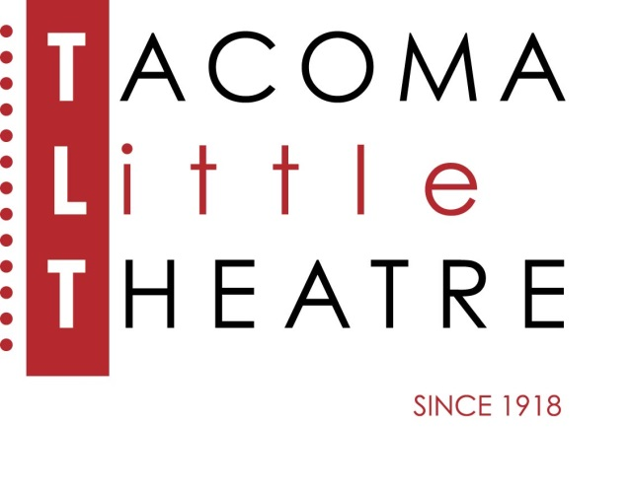
Press Release
210 North I Street, Tacoma, WA 98403 253-272-2281 www.tacomalittletheatre.com
For more information please contact:
Chris Serface, Managing Artistic Director
chris@tacomalittletheatre.com Photos available upon request.

FOR IMMEDIATE RELEASE End Date: November 18, 2013

Tacoma Little Theatre presents
THE WEIR
Tacoma, WA- Tacoma Little Theatre brings the mystery and intrigue of the Irish countryside to life in its production of Conor McPherson’s The Weir, directed by pug Bujeaud.

In a bar in a remote part of western Ireland, three local lads, together with the landlord are swapping spooky stories to impress an attractive young woman. What begins as a simple visit to the local pub soon turns out to be an evening of both funny and spell-binding stories. When the final tale takes a strange and unexpected twist, it changes the whole mood of the evening and marks a significant shift among the chemistry of the group.

This production features some of Puget Sound’s most talented actors: Ellen Peters (Valerie), Gabriel McClelland (Finbar), David Wright (Jack), Brian Wayne Jensen (Jim), and Robert McConkey (Brendan).

The Weir will run Friday, November 8, 2013 until Sunday, November 17, 2013. Friday and Saturday showings are at 7:30pm and Sundays at 2pm. This show is recommended for ages 13+. It contains strong language and some mature content.

Tickets are $12.00 and may be purchased online at www.tacomalittletheatre.com, or by calling our Box Office at (253) 272-2281.
###

