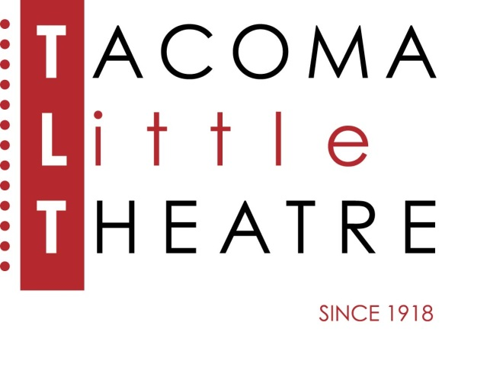
Press Release
210 North I Street, Tacoma, WA 98403 253-272-2281 www.tacomalittletheatre.com
For more information please contact:
Chris Serface, Managing Artistic Director
chris@tacomalittletheatre.com Photos available upon request.

FOR IMMEDIATE RELEASE End Date: December 16, 2013

Tacoma Little Theatre in partnership with
THE CHANGING SCENE THEATRE NORTHWEST
presents
THE SANTALAND DIARIES
Tacoma, WA- Tacoma Little Theatre in partnership with The Changing Scene Theatre Northwest, the Kitsap peninsula's only fringe theatre, presents David Sedaris' irreverent holiday one-man show, The Santaland Diaries about a starving actor in New York City who reluctantly takes a job as an elf at Macy's Department Store.

In what The New York Times calls "a delightfully thorny account of working as a Yuletide elf at Macy's," The Santaland Diaries follows our hero, "Crumpet," through a maze of terrified children, outlandish holiday shoppers, and drunken Santas. This production features Charlie Birdsell as "Crumpet," and isi directed by Pavlina Morris.

For mature elves ages 14+ due to strong language and content.

Two performances only: December 12 and 15, 2013 at 7:30pm, All tickets are $12.00 and may be purchased online at www.tacomalittletheatre.com, or by calling our Box Office at (253) 272-2281.
###

