Harmony of Color
Korean Artists Exhibition
November 4 – December 27, 2013
Asia Pacific Cultural Center Gallery
4851 S. Tacoma Way, Tacoma, WA 98409

Paintings of Jennifer Kwon, Sun Young Kim, Myong Lee, Kyong Oh, Mison Kim:
Five of Harmony of Color members will show their works in oil, acrylic and watercolor paintings.

Since the group’s inception in 2009, the Harmony of Color has focused on the professional and artistic development of its membership, charity giving to community. They have sought opportunities to showcase members’ artworks in a variety of public settings in hope to share their works and to inspire others to also find time in their busy schedule to seek out one’s hidden talent.

As each member of Harmony of Color, they express harmony in nature through their work. They have different style and subject matters in paintings, but they all show the joy and peace in paintings and form a harmony of color.

Currently all members of Harmony of Color are Korean by heritage and may display some traits of Korean culture in their paintings in many ways.

Thus far, they have had Members’ Exhibition at the following venues:

South Bellevue Community Center, Bellevue WA
Local Color, Seattle WA
Essential Market, Seattle WA
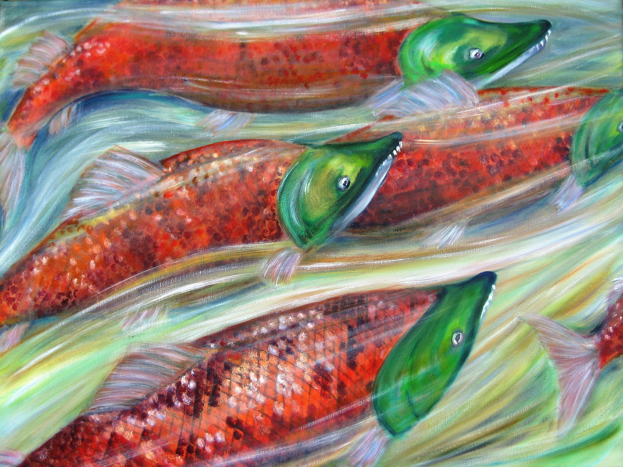
Jennifer Kwon “Salmon”

