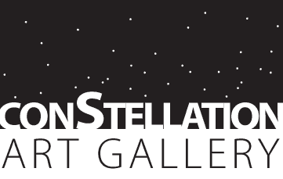

Call for Artists

ConStellation Art Gallery is looking for a few Artists who create upscale gift or home décor items.

Items we are looking for:

- Blown glass sculpture and décor
- Upscale wood-turned pieces and furniture
- High-end ceramic sculpture

There is a membership fee for a 3 month contract. Artists pay $100 a month for wall space or a significant about of floor space ($300 contract), or $45 a month for shelf space - limit 2 shelves ($135). Sales are split 70/30 with 70% going to the artist.

Contracts are for three months, and may be renewed every three months as desired.
If you are interested in being a vendor please contact:
~email: constellationtacoma@gmail.com

