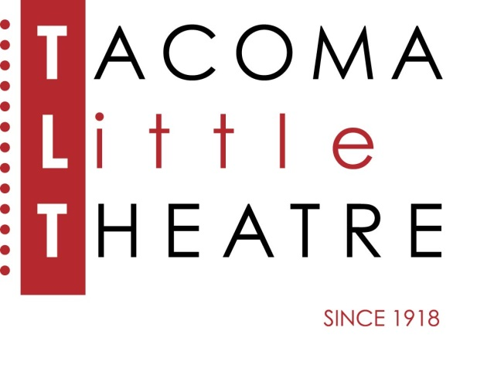
Press Release
210 North I Street, Tacoma, WA 98403 253-272-2281 www.tacomalittletheatre.com
For more information please contact:
Chris Serface, Managing Artistic Director
tlt@tacomalittletheatre.com

FOR IMMEDIATE RELEASE End Date: April 2, 2014

AUDITIONS: MOONLIGHT AND MAGNOLIAS

Tacoma, WA- Tacoma Little Theatre is holding auditions for its production of Moonlight and Magnolias, directed by Pavlina Morris, on March 30th and April 1st.

1939 Hollywood is abuzz. Legendary producer David O. Selznick has shut down production of his new epic, Gone with the Wind, a film adaptation of Margaret Mitchell's novel. The screenplay, you see, just doesn't work. So what's an all-powerful movie mogul to do? While fending off the film's stars, gossip columnists and his own father-in-law, Selznick sends a car for famed screenwriter Ben Hecht and pulls formidable director Victor Fleming from the set of The Wizard of Oz. Summoning both to his office, he locks the doors, closes the shades, and on a diet of bananas and peanuts, the three men labor over five days to fashion a screenplay that will become the blueprint for one of the most successful and beloved films of all time.

Auditions will be held Sunday, March 30th & Tuesday, April 1st at Tacoma Little Theatre. Audition appointments will be set between the times of 7:00pm-9:30pm. Each actor will be asked to perform a 1-2 minute comedic monologue Callbacks will be held on Thursday, April 3rd.

To reserve an audition time, email tlt@tacomalittletheatre.com, or call our Box Office at (253) 272-2281. Please provide: your name, phone number, email address, preferred audition time, and playable age. ALL ROLES ARE OPEN

Once cast, Moonlight and Magnolias will run from Friday, June 13, 2014 to Sunday, June 22, 2014.

###

