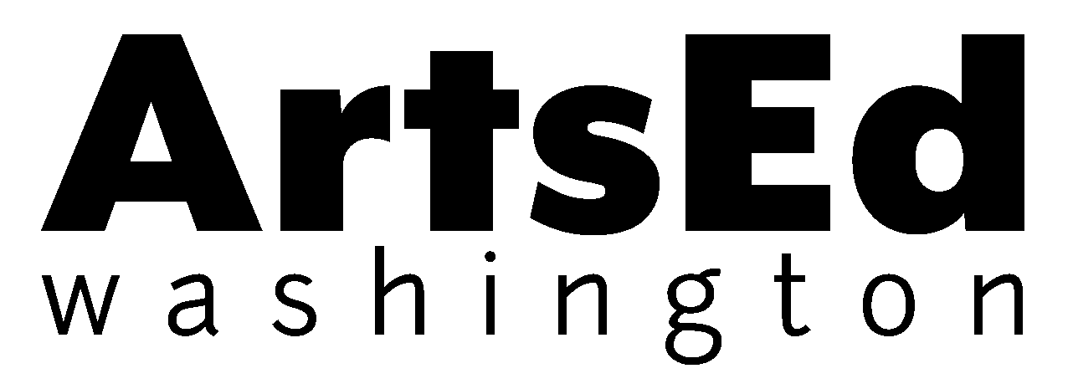

Art Lessons in the Classroom Curriculum Showcase

Tuesday, April 15, 2014
4 to 5 pm
Grant Elementary School, 1018 N. Prospect St. Tacoma, WA 98406

Come sample Art Lessons in the Classroom, ArtsEd Washington’s K-6 visual art curriculum. Adopt the Art Lessons at your school and provide every student with consistent, high-quality instruction. Find out how!
- Step-by-Step lesson plans build on skills sequentially by grade level.
- Aligned with Washington State Arts Standards and Common Core State Standards for English and Math.
- Teacher trainings included as part of implementation, with online video and photo tutorials for ongoing support and refreshers.
- Online teacher resources from museums around the state.
- Assessment tools and criteria empower teachers to easily evaluate student work and learning.
- Includes a Family Letter to send home about each lesson.
The arts (a core subject required by law) help students develop vital 21st century skills like creativity, critical thinking, communication, and collaboration. Art Lessons in the Classroom empowers teachers, regardless of their backgrounds, to provide students with high quality visual art instruction that will help them develop the strengths they need to thrive!
Join us at Grant Elementary for this engaging, informational get together.
PLEASE RSVP TO ATTEND: programs@ArtsEdWashington.org

