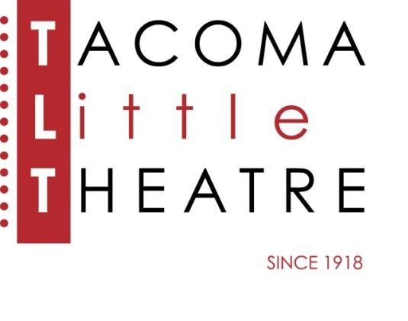
Press Release
210 North I Street, Tacoma, WA 98403 253-272-2281 www.tacomalittletheatre.com
For more information please contact:
Chris Serface, Managing Artistic Director
chris@tacomalittletheatre.com Photos available upon request.

FOR IMMEDIATE RELEASE End Date: June 2, 2014

Tacoma Little Theatre presents
BYE BYE BIRDIE
Tacoma, WA- Bye Bye Birdie perches at Tacoma Little Theatre this May.

Directed by Chris Serface, with Musical Direction by Terry O’Hara and Choreography by Elizabeth Richmond Posluns, this satiric spoof of the “Elvis Craze” will have you laughing and having a great time.

Rock star Conrad Birdie (DuWayne Andrews, Jr.) is the biggest thing to top the charts. Women love him, men want to be him and teenage girls around the country scream with glee at the mere mention of his name. But when the United States Army drafts Birdie, manager Albert Peterson (Steve Barnett) sees his meal ticket preparing to fly the coop (much to the delight of longtime love Rose Alvarez (Ashley Ortenzo), who can’t wait for Albert to ditch the music biz and become something respectable, (like an English teacher). Desperate for a publicity stunt big enough to help them survive Birdie’s departure, Albert and Rose hatch a plan: send Conrad to small-town America to plant his goodbye kiss on one lucky fan for the entire world to see. Their selection of super fan Kim MacAfee (Melissa Maricich) sends the wholesome enclave of Sweet Apple, Ohio into chaos. Kim’s boyfriend, Hugo (Steven Wells), can’t take the humiliation of his lady love’s televised lip-lock. Rose can’t take another minute of Albert’s distracted ways. And Sweet Apple can’t take its teens' riotous rebellion, inspired by the arrival of bad-boy Birdie. Will Sweet Apple ever be the same?.

Bye Bye Birdie will run Friday, May 9, 2014 until Sunday, June 1, 2014. Friday and Saturday showings are at 7:30pm and Sundays at 2pm. This show is recommended for all ages.

Tickets are $25.00-$15.00 and may be purchased online at www.tacomalittletheatre.com, or by calling our Box Office at (253) 272-2281.
###

