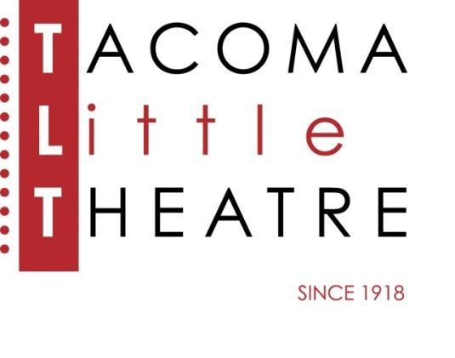
Press Release
210 North I Street, Tacoma, WA 98403 253-272-2281 www.tacomalittletheatre.com
For more information please contact:
Chris Serface, Managing Artistic Director
chris@tacomalittletheatre.com Photos available upon request.

FOR IMMEDIATE RELEASE End Date: July 22, 2014

Tacoma Little Theatre presents
SUMMER CAMP @ TLT
Tacoma, WA- A great way for your students to spend the summer!

Tacoma Little Theatre is now taken enrollments for its SUMMER CAMP @ TLT program. These fun-filled camp sessions help students learn the basics of theatre and prepare a production that is performed at the end of their session. This summer we are offering two different times and three different show choices. All students who enroll in the camp are guaranteed a role. Space for each session is limited.

SESSION #1 JUNE 16-JULY 18, 2014
Rehearsals: Monday-Friday 9:00am-4:00pm
GREASE:School Version-For students in grades 7-12 (Tuition $400.00/$435.00)
FRACTURED FAIRY TALES-For students in grades 1-6: (Tuition $400.00/$435.00)

SESSION #2 JULY 21-AUGUST 8, 2014
Rehearsals: Monday-Friday 9:00am-4:00pm
THE GRUNCH-For students in grades 1-12 (Tuition $350.00/$385.00)

All rehearsals and performances are held at Tacoma Little Theatre 210 N I Street, Tacoma, WA 98403.

For more information or to enroll, contact us at www.tacomalittletheatre.com, 253-272-2281, or by coming by our Box Office during normal business hours.

###

