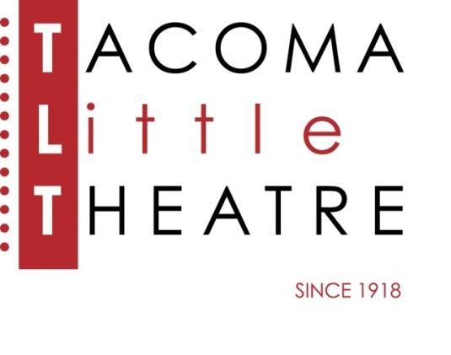
Press Release
210 North I Street, Tacoma, WA 98403 253-272-2281 www.tacomalittletheatre.com
For more information please contact:
Chris Serface, Managing Artistic Director
chris@tacomalittletheatre.com Photos available upon request.

FOR IMMEDIATE RELEASE End Date: June 23, 2014

Tacoma Little Theatre presents
MOONLIGHT AND MAGNOLIAS
Tacoma, WA- The zany comedy, Moonlight and Magnolias, directed by Pavlina Morris, slips onto the TLT stage this June.

It’s 1939 and Hollywood is abuzz. Legendary producer David O. Selznick (Blake York) has shut down production of his new epic, “Gone with the Wind”, a film adaptation of Margaret Mitchell's novel. The screenplay, you see, just doesn't work. So what's an all-powerful movie mogul to do? While fending off the film's stars, gossip columnists and his own father-in-law, Selznick sends a car for famed screenwriter Ben Hecht (Tedd Saint-James) and pulls formidable director Victor Fleming (Jacob Tice) from the set of The Wizard of Oz. Summoning both to his office, he locks the doors, closes the shades, and on a diet of bananas and peanuts provided by the overworked Miss Poppenghul (Katelyn Hoffman), the three men labor over five days to fashion a screenplay that will become the blueprint for one of the most successful and beloved films of all time.

Moonlight and Magnolias will run Friday, June 13, 2014 until Sunday, June 22, 2014. Friday and Saturday showings are at 7:30pm and Sundays at 2pm. This show is recommended for ages 12 and up.

Tickets are $12.00 and may be purchased online at www.tacomalittletheatre.com, or by calling our Box Office at (253) 272-2281.
###

