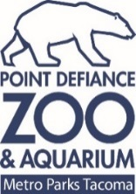
FOR IMMEDIATE RELEASE: March 19, 2019
“TURTLE WAVE” COMMUNITY ART TO HELP SAVE THE OCEAN
A month-long celebration of Point Defiance Zoo & Aquarium’s new Pacific Seas Aquarium will culminate
April 26-28 with a huge community artwork designed to help the ocean – and the animals that live there
TACOMA, Wash. – Catch an inspired wave of art to help save the ocean.

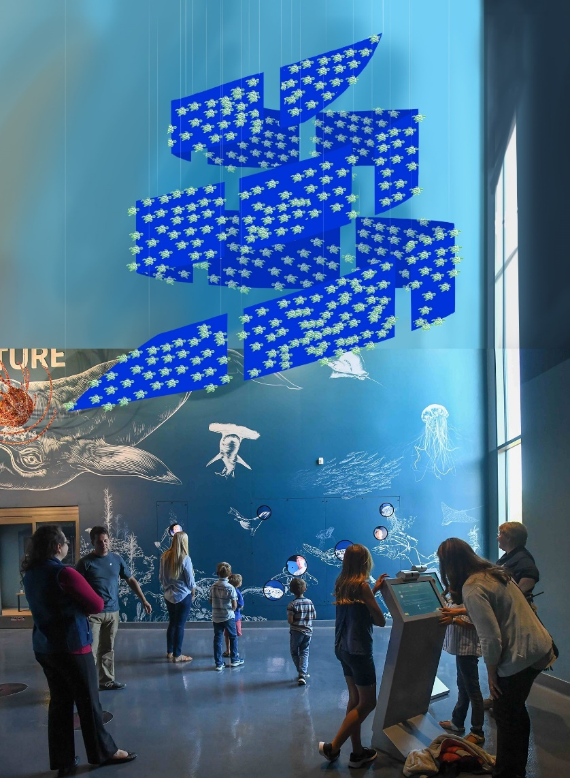
Imagine hundreds of paper turtles - constructed and colored by legions of community members -swimming on a blue silk wave hanging in the new Pacific Seas Aquarium.

Nearby, real green sea turtles swim placidly, accompanied by hammerhead sharks, spotted eagle rays and hundreds of colorful subtropical fish.

That’s the vision for “Turtle Wave,” a community artwork being created at Metro Parks Tacoma facilities and elsewhere in the community over the next few weeks, with a grand finale scheduled April 26-28 inside the Pacific Seas Aquarium at Point Defiance Zoo & Aquarium.

The “Turtle Wave” is part of the Pacific Seas Aquarium Community Celebration, a jam-packed month of events to celebrate the state-of-the-art aquarium that is home to a large array of amazing sea creatures.

Artist’s rendering shows what the ‘Turtle Wave’ will look like
once completed and hung in the Pacific Seas Aquarium.
But “Turtle Wave” will be more than a sculpture. Every paper turtle folded, cut sculpture. Every paper turtle folded, cut or colored will raise $2 to support ocean conservation youth leadership, thanks to the Bezos Family Foundation and the worldwide Ocean Art Challenge. Participants will be encouraged to pledge personal action to help the ocean.

“This is a brilliant way to get people thinking and caring about the ocean,” said Karen Povey, conservation engagement manager at Point Defiance Zoo & Aquarium. “Ocean creatures are at risk, but together we can make a wave of change – literally, in this case.”

The zoo, a facility of Metro Parks Tacoma, is working with other Metro Parks staff to create opportunities for community members, zoo visitors and members, and others to make the paper turtles and glue them onto blue fabric “waves.” The resulting artwork will be suspended from the soaring ceiling near the Pacific Seas Aquarium’s Baja Bay exhibit.

Turtle-making days open to the public include:
- April 6, 10 a.m. to noon during Spring Fling at The Center at Norpoint, 4818 Nassau Ave. N.E.
- April 13, 1 p.m. to 3 p.m., during the Egg Hunt at People’s Center, 1602 Martin Luther King Jr. Way, Tacoma
- April 13, 10 a.m. to noon, during Spring Fling at STAR Center, 3873 S. 66th St., Tacoma
- April 13, 10 a.m. to noon, during Spring Fling at People’s Center, 1602 Martin Luther King Jr. Way, Tacoma
- April 20, 11 a.m. to 1 p.m. during Spring Fling at Eastside Community Center, 3513 Portland Ave. E., Tacoma
- April 20, Noon to 4 p.m. during Earth Day at Tacoma Nature Center, 1919 S. Tyler St., Tacoma
- April 26-28, 10 a.m. to 4 p.m., in the Pacific Seas Aquarium at Point Defiance Zoo & Aquarium, 5400 N. Pearl St., Tacoma

Turtles also will be made by patients at Mary Bridge Children’s Hospital, which is sponsoring the Community Celebration, and at Metro Parks staff events. People also can make turtles at home and bring them to the zoo to raise even more money for ocean conservation. Go to www.pdza.org/turtle-wave for more details and a pattern.

After the “Turtle Wave” weekend at the zoo, the art will travel to other Tacoma venues this summer, including Eastside Community Center, Tacoma Ocean Fest, and more.

“This is something community members can do to both exercise their creative side and help our ocean,” said Mary Tuttle, programs manager at Metro Parks. “Art inspires us to care about our world.”

The turtle art will cap a month-long celebration of the Pacific Seas Aquarium. April will be packed with events, from dives and feeds to film, science speakers, storytelling and music. All events at the zoo are free with zoo admission or membership. Events in the community are free.

The entire schedule is available at www.pdza.org/aquarium-celebration.

“We were very proud of the aquarium when it opened on Sept. 7,” said Alan Varsik, director of Zoological and Environmental Education for Metro Parks Tacoma. “And we are even more proud today. Over the last several months, our staff has worked hard to include even more animals, and we are more adept at telling the stories of the inspiring sea creatures inside. It’s time to celebrate, and we invite the community to come and join us.”

The 35,000-square-foot, state-of-the-art Pacific Seas Aquarium was funded largely through bonds approved by Tacoma voters in 2014. Additional monies for construction were provided by The Zoo Society through corporate and individual donors, and grants.
###
Point Defiance Zoo & Aquarium, the Northwest’s only combined zoo and aquarium, practices and promotes responsible stewardship of the world’s resources. A member of the Metro Parks Tacoma family, the zoo creates a legacy of sustainability for future generations through education, conservation, research and recreational opportunities; it also embodies Metro Parks’ mission of creating healthy opportunities to play, learn and grow. The zoo is accredited by the Association of Zoos & Aquariums (AZA) and the Alliance of Marine Mammal Parks and Aquariums (AMMPA).

Contacts
Kris Sherman, 253-226-6718; kris.sherman@pdza.org
Whitney DalBalcon, 253-404-3637; 253-278-6343 or whitney.dalbalcon@pdza.org

