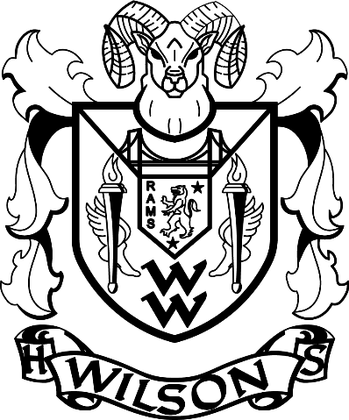
Press Release
For more information or to arrange press passes, please contact:
Wilson High School
1202 N Orchard Street, Tacoma, WA 98406 (253) 571-6000
Chris Serface, Drama Director
cserfac@tacoma.k12.wa.us

FOR IMMEDIATE RELEASE End Date: April 21, 2019
WILSON HIGH SCHOOL PRESENTS
DISNEY’S BEAUTY AND THE BEAST

Tacoma, WA-Wilson High School presents a tale as old as time, Disney’s Beauty and the Beast. The show will come to life on the Wilson High School stage April 12-April 20, 2019.

Be swept away into this enchanted musical where Belle feels trapped in a provincial town and a prince is trapped in the body of a hideous beast. If the beast can learn to love and be loved, the spell will be broken and he will be transformed to his former princely self. If not, he and his household will be doomed for all time. This classical musical love story is a magical tale that comes to life with unforgettable characters, and a stunning score including, "Be Our Guest," "Gaston," "Human Again," and the Oscar-winning title song, "Beauty and the Beast."

Disney’s Beauty and the Beast is directed by Chris Serface, musically directed by Jeff Bell, and choreographed by Ashley Roy. This production features 30 of Wilson High School's most talented actors, singers, dancers, and technicians. Don't miss the fun!

Disney’s Beauty and the Beast will run Friday, April 12, 2019 through Saturday, April 20, 2019. Showtimes are Friday & Saturday at 7:00pm with special matinee performances on Sunday, April 14th & Saturday, April 20th at 2:00pm. There will also be a weeknight performance on Thursday, April 18th at 7:00pm. This show is recommended for all ages.

Tickets are $10.00 for all seats. Tickets may be purchased online at (https://www.brownpapertickets.com/event/4109189), or in person at the auditorium before each performance.

All performances are held at Wilson High School, 1202 N Orchard Street, Tacoma, WA 98406 (253) 571-6000.

###

