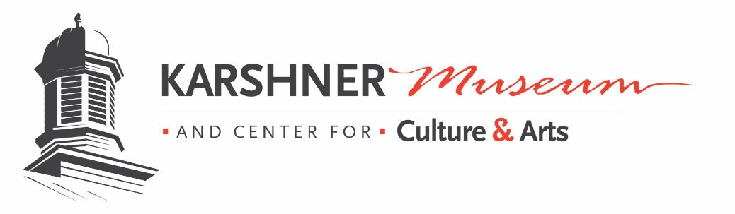
309 4th St NE Puyallup, WA 98372 253.841.8748

CALL FOR ART

“WET MUD, FRESH PAINT” Artist in Action Festival
May 4, 2019 Noon to 5 pm
Artists are needed to demonstrate their craft and entries are needed in a variety of mediums and styles for an art show running from May 3-May 24.
People’s Choice and Best of Medium awards given.

Please fill out the entry form and questionnaire below and return to Lynda Belt, Karshner Museum and Center for Culture & Arts at beltld@puyallup.k12.wa.us. For more information email or call 253.841.8748
PERSONAL AND CONTACT INFORMATION
First Name-
Last Name-
Business Name-
Address-
City-
State and Zip-
Phone-
Email-
Website-

DEMONSTRATIONS
Would you be interested in doing a demonstration of your craft? The goal of the day is to have as many artists of different styles, mediums, and crafts demonstrate. You can sign up to demonstrate all day or in 2 1/2 hour blocks. You can have a partner share the workload with you.
Yes_____________ No __________________ I prefer 12-2:30 ________ 2:30-5_________
Either time is fine____________ I will demonstrate all day _______________________
ART SHOW ENTRIES
I would like enter a piece of art work into the mixed media art show. You may enter in two different categories
Select Media:
Painting – ___________ Medium used _______________________
Photography________________
Drawing- _______________ Medium used_____________________
Calligraphy-_____________ Collage -_________________________
Leather-________________ Wood-__________________________
Glass- _________________ Sculpture-_________________ Assemblage-________________
Pottery-________________ Rock cutting, lapidary-___________________________
Paper/Mixed Media - ____________________ Type-___________________________
Printmaking: ____________ Type-__________________________
Jewelry-_______________ Metal Works-____________________
Fabric-________________ Weaving-_______________________
Other-________________ Mediums used___________________
- Please attach one or two images of artwork you would like to enter to email and give titles of pieces please.
- You will be notified if you piece is selected.
- Dates for drop off of art work are May 1-2. Make sure label is on back clearly giving Title, Medium, Artist Name and phone or email.
- Show runs May 4-May 24. Art show is open to public May 4 noon to 5 pm. During Wet Mud Fresh Paint Festival.
May 6,8,9,10,13,14,15 Open 2 pm-4 pm May 16 2 pm-8 pm
- Artist reception is May 20 6-8 pm with refreshments and awards given.
- Art is to be picked up May 22-24 from 2-4 pm or by special arrangement (Field trips during the day and School District Professional Development from 4 on most days. )

