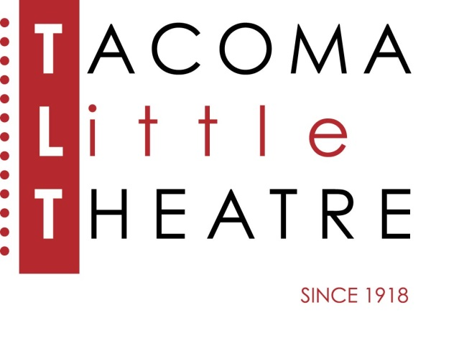
Press Release
210 North I Street, Tacoma, WA 98403 253-272-2281 www.tacomalittletheatre.com
For more information please contact:
Chris Serface, Managing Artistic Director
tlt@tacomalittletheatre.com

FOR IMMEDIATE RELEASE End Date: May 20, 2019
TACOMA LITTLE THEATRE PRESENTS
MOBBED UP FOR MURDER
A MURDER MYSTERY DINNER

Tacoma, WA- Tacoma Little Theatre makes you a part of the mob with Mobbed Up for Murder at The Social Bar and Grill. Directed by Karen Christensen and written by Paula Hilton, this murder mystery dinner experience will have you feeling like you’re in a Francis Ford Coppola movie.

Don Provolone orchestrates a meeting at his favorite restaurant with Don Spumoni and Don Cannoli. They've been to the mattresses for awhile, and quite frankly, his back is killing him! He thinks it's time to let bygones be bygones and has come up with a deal they cannot refuse. Or can they? Don't miss out - you'll want to meet these three colorful Don's along with Toni "Two Times" Tortano, Marisa Macaroon, and Olivia Ascolane. Who will come heavy? Who's on the lam? Who's in the wind? And what does that all mean? Join us to find out, but be careful, the mob means business... and the mob means murder! Featuring the talents of: Virginia Yanoff, Dana Messina Galagan, Grace Nirschl, Jim Rogers, Kerry Bringman, and Nathaniel Walker.

Dinner includes: Appetizer, Salad, Main Entrée (Meat, Chicken, Vegetarian/Gluten Free) & Dessert. Coffee, Tea, Water and Soda are included, and alcohol is available for purchase at the bar or from your server.
MOBBED UP FOR MURDER will run May 16-May 19, 2019. Thursday-Saturday performances will begin at 7:30pm, and the Sunday performance will begin at 3:00pm. The event is held at The Social Bar and Grill, 1715 Dock Street, Tacoma, WA. RESERVATIONS ARE REQUIRED.
Tickets are $55.00 per person (includes dinner with gratuity and show) and may be purchased online at www.tacomalittletheatre.com, or by calling our Box Office at (253) 272-2281.
###

