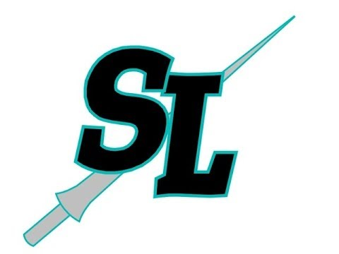
Press Release
For more information or to arrange press passes, please contact:
Spanaway Lake High School
1305 168th Street East, Spanaway, WA 98387 (253) 683-5600
Evan Hildebrand, Drama Director
ehildebran@bethelsd.org

FOR IMMEDIATE RELEASE End Date: May 13, 2019
SPANAWAY LAKE HIGH SCHOOL PRESENTS
FREAKY FRIDAY

Spanaway, WA-Spanaway Lake High School presents the classic comedy about switching places, Freaky Friday, in a brand new musical form fresh from The Disney Channel. This production is directed by Evan James Hildebrand, with musical direction by Rico Lastrapes, and choreography by Sarah Canton.

The new musical, Freaky Friday, based on the beloved 1972 novel by Mary Rodgers and the hit Disney films, features a book by Bridget Carpenter and music and lyrics by Tom Kitt and Brian Yorkey – the Pulitzer Prize-winning composers of Next to Normal and If/Then.

When an overworked mother and her teenage daughter magically swap bodies, they have just one day to put things right again. It is a heartfelt, comedic, and unexpectedly emotional update on an American classic. By spending a day in each other’s shoes, Katherine and Ellie come to appreciate one another’s struggles, learn self-acceptance, and realize the immeasurable love and mutual respect that bond a mother and daughter.

Freaky Friday features the talents of: Cas DePoister, Larissa Gaulke, Shmuel Rios, Jonathan DePoister, Aurelia Lazzaro, Kaylee Christensen, Madison Cadwell, Mandi Murray, Cameron Johnson, Amelia Bee, Katlyn Cook, Shatavia De’Loach, Foeziah Fahemtulla, Heidi Garcia-Martinez, Jordan Jones-Moore, Toby Madakor, Brandon New, Victoria Parson, Juniper Reuther, Kaysee Rhodes, Tyler Ruiz, Kairi Stallsmith, Richard Thomas, and Selena Vargas.

Freaky Friday will run Friday, May 3, 2019 until Sunday, May 12, 2019. Friday & Saturday showings are at 7:00pm and Sundays at 3:00pm. There will also be a special Thursday show on May 9th at 7:00pm. This show is recommended for all ages.

Tickets are $7.00 with ASB and $10.00 for all others. Tickets may be purchased in person at the auditorium.

All performances are held at Spanaway Lake High School, 1305 168th Street East, Spanaway, WA 98387
###

