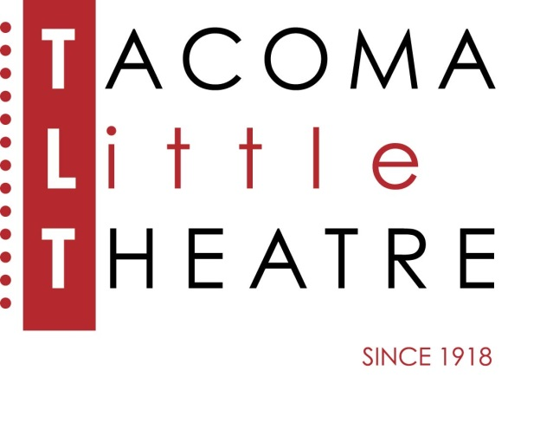
Press Release
210 North I Street, Tacoma, WA 98403 253-272-2281 www.tacomalittletheatre.com
For more information please contact:
Chris Serface, Managing Artistic Director
chris@tacomalittletheatre.com

FOR IMMEDIATE RELEASE End Date: June 24, 2019
TACOMA LITTLE THEATRE PLAY ADVANCES TO
NATIONAL FINALS

(April 25, 2019 Tacoma, WA) Tacoma Little Theatre’s production of The Pillowman, a 2003 play by Irish writer Martin McDonagh, took top honors at the American Association of Community Theatre: Region IX competition in Spokane, Washington, April 18 through 20. Its director, Blake R. York, along with his cast, thereby qualified to compete in national finals held June 18 through 22 in Gettysburg, Pennsylvania.

“I am at a loss for words on how proud I am of this cast and crew,” said Chris Serface, Managing Artistic Director for Tacoma Little Theatre. “This is a testament of the quality of theatre in our Puget Sound community. During the last festival we were proud to cheer on our fellow Tacoma theater, Tacoma Musical Playhouse, as it made this journey.” York won AACTFest Region IX’s award for best director. This was his first time helming an adult, mainstage production, but he’s been TLT’s resident technical director since 2014. A frequent actor on area stages, he’s also designed sets for troupes all over the southern Puget Sound region. His wife, Jen York, won an award for her contributions to The Pillowman’s interrogation-room setting, while Michele Graves won for best costumes.

Top individual-acting awards went to members of Bellingham (Washington) Theatre Guild and The Verona Studio (Salem, Oregon). Regional adjudicators, however, bestowed a special award for ensemble acting on The Pillowman cast for the contest’s one-hour abridgement. That quartet comprises Christian Carvajal, Andrew Fry, Sean Neely (named best actor at the state festival in Prosser, Washington) and Jacob Tice. Its stage manager, both on stage at TLT and in competition, is Nena Curley.

“This is such a Cinderella story,” said Carvajal. “We’re all in total shock about it. We were only moved forward to regionals when another team couldn’t make the trip, so it’s especially gratifying for us to earn a spot now among the best of the best. We feel we represent those other teams as well.”

Given that a weeklong trip to Pennsylvania wasn’t in TLT’s expected budget, Serface is actively soliciting donations. “We can always use donations of money, of course,” Serface noted, “but we could also use air miles, lodging and travel connections, gas cards — anything you think will help TLT represent Tacoma and the other, outstanding community theaters of Washington State. We will be attempting to raise $15,000 in 52 days. I’m confident our wonderful community will help us reach that goal.” People wishing to donate are encouraged to contact Serface at (253) 272-2281 or visit TLT’s website (www.tacomalittletheatre.com).
# # #

ABOUT THE PLAY
In an unnamed totalitarian state, police officers Tupolski (Andrew Fry) and Ariel (Christian Carvajal) question a writer, Katurian (Jacob Tice), about the grisly content of many of his stories. Details of a recent string of child murders echo those stories, casting suspicion on Katurian and his brother, Michal [sic] (Sean Neely). The Pillowman won the New York Drama Critics’ Circle Award for best new foreign play, the Olivier Award for best new play and two Tony Awards (for lighting and scenic design) in 2005.

ABOUT AACT (www.aact.org)
AACTFest 2019 is the culmination of a two-year cycle of state and regional play festivals, and will feature 12 community-theater productions from across the United States and overseas U.S. military that received top honors in their own respective festivals. These winners represent the best community theater America has to offer. Performances of the AACT national companies will start on Tuesday, June 18, in Gettysburg College’s beautifully restored Majestic Theater on Lincoln Square. Additional festival activities will be offered in the adjacent Gettysburg Hotel. The AACTFest 2019 National Festival includes a theater-management pre-conference, youth-leadership conference and festival, educational workshops, top vendor displays, design and monologue competitions, social events, sightseeing, networking opportunities, and an end-of-the-week awards ceremony and celebration.

# # #

TACOMA LITTLE THEATRE
- Currently in its historic 100th season
- Next show: Laura, April 26 - May 12
- Fridays and Saturdays at 7:30 p.m., Sunday matinées at 2 p.m.
- Ticket prices: $20-$25
www.TacomaLittleTheatre.com

Photo Credits:
Blake York Director-photo by Dennis K Photography
TLTThePillowmanScene-(l to r) Jacon Tice (Katurian), Christian Carvajal (Ariel) & Andrew Fry (Tupolski) photo by Dennis K Photography
TLT Pillowman Awards- (l to r) Blake York, Sean Neely, Andrew Fry, Christian Carvajal & Jacob Tice

