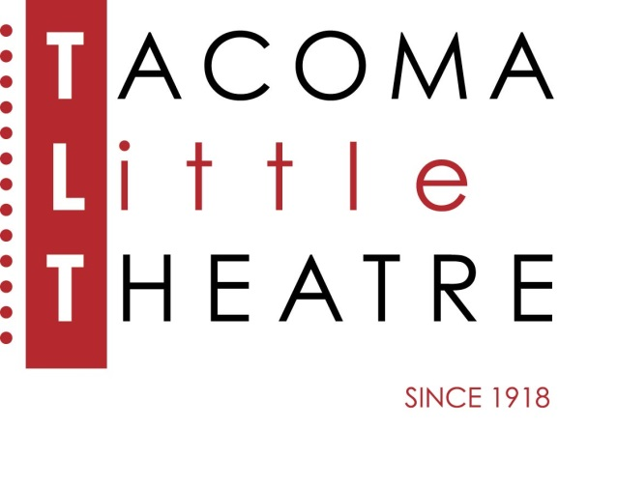
Press Release
210 North I Street, Tacoma, WA 98403 253-272-2281 www.tacomalittletheatre.com
For more information please contact:
Chris Serface, Managing Artistic Director
tlt@tacomalittletheatre.com

FOR IMMEDIATE RELEASE End Date: August 25, 2019
AUDITIONS: EVIL DEAD: THE MUSICAL
AUGUST 18th & AUGUST 19TH
Tacoma, WA- Tacoma Little Theatre is holding auditions for its production of the cult-classic, Evil Dead: The Musical, cased on the classic 80’s film, and directed by Niclas Olson with musical direction by Benjamin Bentler, and choreography by Ashley Roy.

Auditions will be held Sunday, August 18th and Monday, August 19th at Tacoma Little Theatre. Audition appointments will be set between the times of 6:00pm-9:00pm on Sunday and 7:00pm-10:00pm on Monday in five-minute increments. Callbacks will be held on Wednesday, August 21st.

Five college students go to an abandoned cabin in the woods and accidentally unleash an evil force that turns them all into demons. It's all up to Ash (a housewares employee turned demon-killing hero) and his trusty chainsaw to save the day. Blood flies. Limbs are dismembered. Demons tell bad jokes ... and all to music. This show has fun with the horror genre and, in doing so, appeals to a wide audience. It's the only show with a "Splatter Zone"—a section of the audience that gets covered in fake blood. And with this combination of blood, jokes, cheesy effects and awesome musical numbers, Evil Dead The Musical is unlike any show you've ever seen.

Auditioners are asked to prepare a verse and a chorus (apx 32 bars) from a contemporary musical theatre song, and a short, 1-2 minute, comedic monologue. Audition material should be a maximum of 3 minutes combined and highlight your vocal range and versatility as a performer. An accompanist is provided, so please bring sheet music clearly marked and in the correct key.

Actors of all ethnicities and gender identities are encouraged to audition and all roles are available: Ash (male 18-25), Cheryl (female 18-25), Annie/Shelly (female 20-30), Scott (male 18-25), Linda (female 18-25), Ed/Moose (male 20-30), Jake (male 30-40), Fake Shemp (m/f 20-30). All actors will double in other roles including Professor Knowby, the Severed Hand, Linda’s headless body, etc. Ages given are playable ages, actors need not specifically fit the given age to audition.

To reserve an audition time, follow this link (http://castingmanager.com/audition/info/lzpERMZM3V6BePA), or call our Box Office for assistance at (253) 272-2281.

Once cast, Evil Dead: The Musical will run from Friday, October 25, 2019 to Sunday, November 10, 2019.

###

