PUGET SOUND POETRY CONNECTION
DISTINGUISHED WRITER SERIES

FRIDAY AUGUST 9
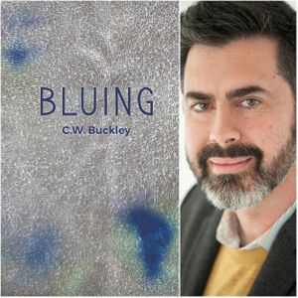
FEATURED READER – CHRISTOPHER BUCKLEY

A fourth generation West Coast native, Christopher Buckley lives and works in Seattle. He graduated at Stanford University with a degree in Human Biology, then also earned an MA in Religion. He worked for two years as a chaplain resident in children’s hospitals.

He describes himself as “Corporate by day, Catholic by faith”. His writing explores geek culture, conscience, faith and fatherhood. His work has appeared in or is forthcoming in Raven Chronicles, Rock and Sling, Lummox Journal, and Image Journal among others. His chapbook Bluing is recently published by Finishing Line Press. You can follow him at @chris_buckley on Twitter

Reading at Immanuel Presbyterian
901 N J Street Tacoma WA 98103
Doors open at 7 PM
Reading in Basement Fellowship Room – Enter from Parking Lot

Open mic follows the featured reader. All are welcome to sign up.

