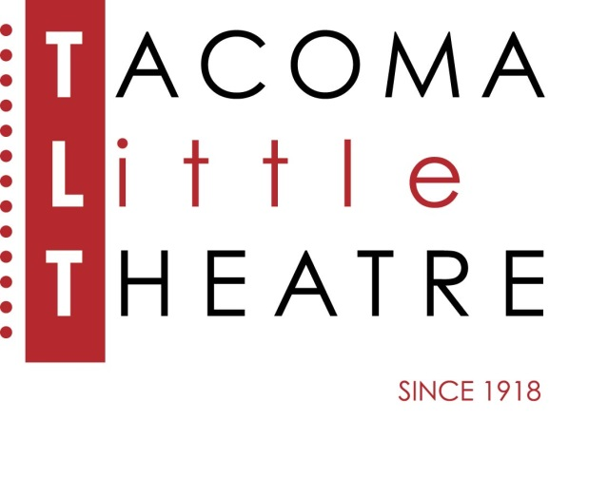
Press Release
210 North I Street, Tacoma, WA 98403 253-272-2281 www.tacomalittletheatre.com
For more information please contact:
Chris Serface, Managing Artistic Director
tlt@tacomalittletheatre.com Photos available upon request.

FOR IMMEDIATE RELEASE End Date: September 8, 2019

TACOMA LITTLE THEATRE presents their 101ST Season OPENING GALA
AND SILENT AUCTION
Tacoma, WA- Tacoma Little Theatre is excited to welcome the community to join us at our special Gala and Silent Auction celebrating our 101st Season. This special fundraising event will be filled with fine drinks, fine hors d’oeuvres, and fine entertainment.

The evening will begin with a social hour and then move into the auditorium where staff and board members will present a sneak peek of each of the shows in our 101st season which include: Calendar Girls, Evil Dead: The Musical, Holmes for the Holidays, ‘Twas the Night Before Christmas, Shattering, A Chorus Line, Terms of Endearment, and The Manchurian Candidate. Throughout the course of the evening attendees will be bidding on silent auction items and enjoying musical entertainment from local performers.

Tacoma Little Theatre’s 101st Season Opening Gala and Silent Auction will take place on Saturday, September 7, 2019 from 6:00pm-9:00pm.

Tickets are $35.00 per person (includes hors d’oeuvres and one drink) and may be purchased online at www.tacomalittletheatre.com, or by calling our Box Office at (253) 272-2281.

###

