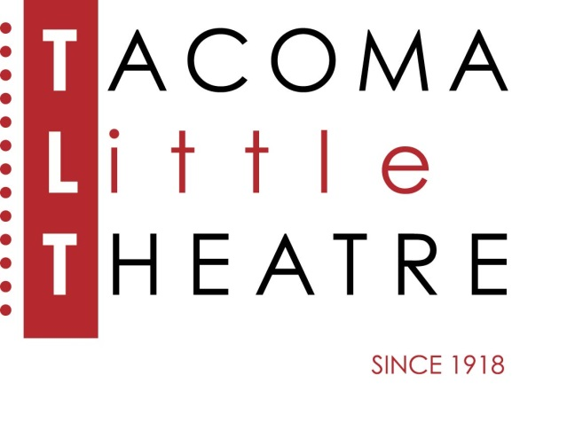
Press Release
210 North I Street, Tacoma, WA 98403 253-272-2281 www.tacomalittletheatre.com
For more information please contact:
Chris Serface, Managing Artistic Director
tlt@tacomalittletheatre.com Photos available upon request.

FOR IMMEDIATE RELEASE End Date: September 13, 2019

TACOMA LITTLE THEATRE ANNOUNCES ITS
101st SEason
Tacoma, WA-Tacoma Little Theatre is delighted to announce their 101st SEASON of theatre beginning in September.

TLT is calling this season “A SEASON OF FIRSTS”, because it truly is! All the shows that are part of the season have never been performed on the TLT stage. The season starts with a touching comedy about life and death, Calendar Girls; then Evil Dead: The Musical, a creepy and campy show based on the 80’s cult classic horror movie will bring a “splatter zone” just in time for Halloween; Holmes for the Holidays, a new holiday comedy mystery from author Ken Ludwig; A world premiere new work that TLT was selected to present by the American Association of Community Theatre, Shattering; The Broadway classic, A Chorus Line; a brand new script based on the Academy Award winning film Terms of Endearment; and finally just in time for an election season, The Manchurian Candidate. As a special bonus for our family audiences, TLT will present a new show, ‘Twas the Night Before Christmas, during the holiday season.

Single Tickets, Season Tickets, and FLEX passes are now available by visiting www.tacomalittletheatre.com, calling 253-272-2281, or coming in person to our box office (Tuesday-Friday 1:00pm-6:00pm). Season Tickets range in price from $120.00-$145.00. and FLEX passes are $135.00.

We hope that you’ll join Washington’s oldest award-winning community theatre as it begins a new century of bringing the Performing Arts to the northwest!

###

