A Call for Art !!! 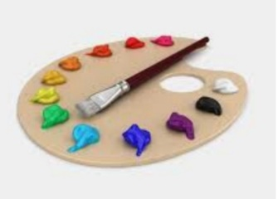

Women Veteran Art Exhibit with the Veterans Administration:
Partnering with the Department of Veterans Affairs (VA) Center for Women Veterans and the Veteran Health Administration (VHA), the Womens Veteran Art Project* offers the call for artwork created by women veterans for display at several VA medical centers around the United States. The call for artwork “portfolio samples” begins August 1st 2019 and ends August 23. This is to help with artist selection, not necessarily choose the actual artworks. Completed artworks qualify for submission also. Each VA has an Ambassador working with the artists. Each VA medical center will have their own local art exhibit, created by local women veteran artists. The Exhibit will launch in November 2019 (unless otherwise arranged).
Guidelines: Women veteran artists are invited to submit 3-5 high resolution digital images of their art portfolio to their Ambassador Carlene Salazar at carlene.salazar@gmail.com. To clarify – the digital images are “examples” only and do not necessarily have to represent the finished piece(s). The art work must be completed by Mid October for VA review. No theme is required but art should be “family friendly”. Goal is to honor Women Veterans for service. The art sizes, mediums and amount will depend on the VA’s facility capability for display to be worked out between the Ambassador and the VA POC. (example, pedestals for sculpture, wall space or easels for art pieces, etc). There is no fee to enter or exhibit. This first exhibit for this region will be in the Walla Walla VA facility. Final accepted art will be either hand delivered or shipped. Other arrangements by specific request. Full instruction to follow artist’s response of interest.
*backed by the non-profit Veterans Art Venue
Thank you for helping to honor the service of Women Veterans through their artwork

