PUGET SOUND POETRY CONNECTION
DISTINGUISHED WRITER SERIES

FRIDAY SEPTEMBER 13
FEATURED READER – ROBERT HASSELBLAD

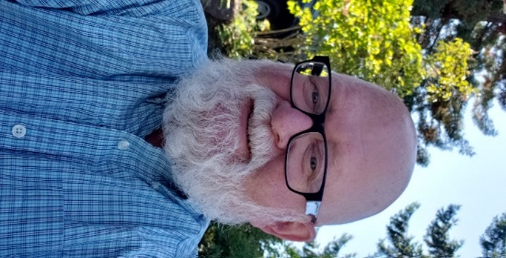
Robert Hasselblad began writing poetry while a student at Pacific Lutheran University. He has been tinkering with language and imagery ever since. Recently retired from 43 years in the lumber industry, he lives in Tacoma and is a long-time member of Puget Sound Poetry Connection.

Robert has been published in many literary journals and anthologies. Current poems either appear or are forthcoming in riverbabble, Door is a Jar, Tipton Poetry Journal, The Big Windows Review, Avalon Literary Review, K’in and Saxifrage.

Reading at Immanuel Presbyterian
901 N J Street Tacoma WA 98103
Doors open at 7 PM
Reading in Basement Fellowship Room – Enter from Parking Lot

Open mic follows the featured reader. All are welcome to sign up.

