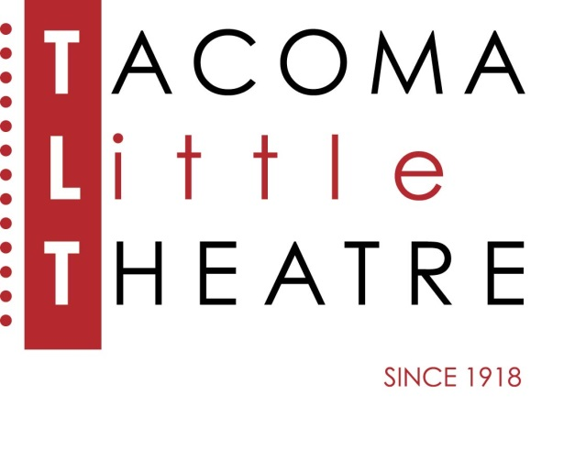
Press Release
210 North I Street, Tacoma, WA 98403 253-272-2281 www.tacomalittletheatre.com
For more information please contact:
Chris Serface, Managing Artistic Director
tlt@tacomalittletheatre.com

FOR IMMEDIATE RELEASE End Date: October 3, 2019
AUDITIONS: ‘TWAS THE NIGHT BEFORE CHRISTMAS
SEPTEMBER 29th & SEPTEMBER 30th
Tacoma, WA- Tacoma Little Theatre is holding auditions for its production of the holiday classic, ‘Twas the Night Before Christmas, written by comedy genius Ken Ludwig (Lend Me A Tenor). The production will be directed by Mary Ellen Gilmour.

Auditions will be held Sunday, September 29th and Monday, September 30th at Tacoma Little Theatre. Audition appointments will be set starting at 6:00pm on Sunday and 7:00pm on Monday in five-minute increments. Callbacks will be held on Wednesday, October 2nd.

‘Twas the night before Christmas, and all through the house, creatures were stirring, including a mouse! Kick off your family’s yuletide season with this comic take on the classic poem. When Santa’s Naughty or Nice list has gone missing, it’s up to a pair of dancing mice, a spunky girl, and an Elf-B-I agent to solve the mystery before Santa boards his sleigh.

Auditioners are asked to prepare a short, 1-2 minute, contemporary comedic monologue.

Actors of all ethnicities and gender identities are encouraged to audition and all roles are available: Uncle Brierly/Sir Guy of Gisbourne (male 50-60), Emily (female 10-15), Amos/Amos of Kansas (male 10-15), Calliope/Britannia Sneed (female 20-30), and Mulch/Santa Claus/Wendell Sneed (male 20-40). Ages given are playable ages, actors need not specifically fit the given age to audition.

To reserve an audition time, follow this link (http://castingmanager.com/audition/info/W76wQb6DeAiVYd2), or call our Box Office for assistance at (253) 272-2281.

Once cast, ‘Twas the Night Before Christmas will run eight performances from Saturday, December 14, 2019 to Saturday, December 28, 2019.

###

