Auburn: Cheryl Sallee Gallery
Angela Marvel
Contact:
Allison Hyde, Art Coordinator
253-804-5043 ahyde@auburnwa.gov

FOR IMMEDIATE RELEASE: September 11, 2019
___________

The City of Auburn and the Auburn Arts Commission are pleased to present the work of Angela Marvel at the Cheryl Sallee Gallery, on view September 12th – November 12th, 2019.

Artist Angela Marvel is a self-portrait artist who creates “conceptual photographic art.” She creates very dream-like imagery in her photography, utilizing elements that are “random, whimsical and multi-faceted that when blended together reveal a moment in a story.”

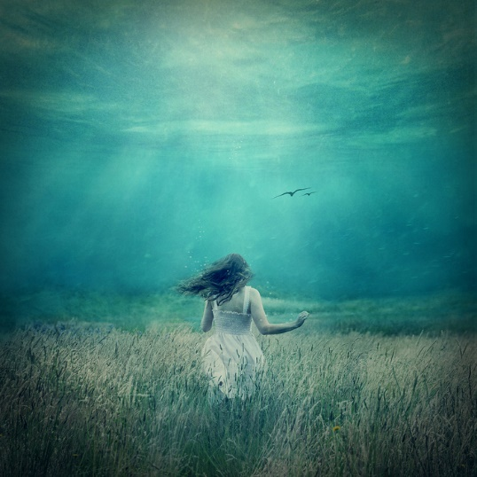

Deep Wandering, Angela Marvel
Photography.

Cheryl Sallee Gallery
Auburn Senior Center - 808 9th St SE, Auburn, WA 98002
Monday - Thursday 8am-9pm, Friday 8am-5pm
____________________________________________________________________________

This art installation is coordinated through the City of Auburn, Parks, Arts & Recreation Department and with the support of the Auburn Arts Commission.

Questions? Contact Allison Hyde, Art Coordinator at 253-804-5043 or ahyde@auburnwa.gov.

Information on City of Auburn cultural arts program can be found at www.auburnwa.gov/arts or call 253-931-3043.

