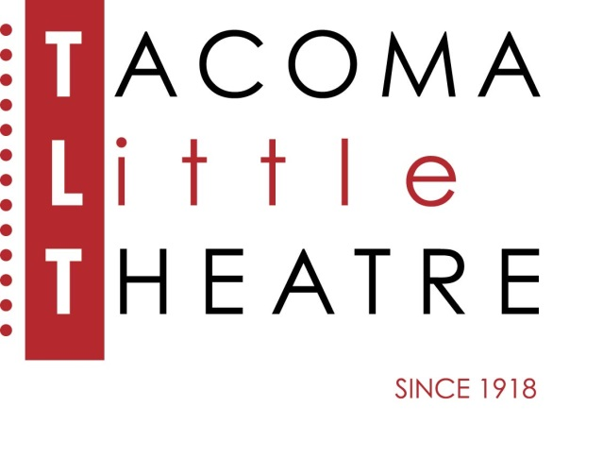
Press Release
210 North I Street, Tacoma, WA 98403 253-272-2281 www.tacomalittletheatre.com
For more information please contact:
Chris Serface, Managing Artistic Director
tlt@tacomalittletheatre.com

FOR IMMEDIATE RELEASE End Date: November 11, 2019
TACOMA LITTLE THEATRE PRESENTS
EVIL DEAD: THE MUSICAL

Tacoma, WA- Tacoma Little Theatre continues its 101st season, A SEASON OF FIRSTS, with the musical version of everyone’s favorite cult horror film, Evil Dead: The Musical. This production is directed by Niclas Olson, musically directed by Benjamin Bentler, and choreographed by Ashley Roy.

Five college students go to an abandoned cabin in the woods and accidentally unleash an evil force that turns them all into demons. It's all up to Ash (a housewares employee turned demon-killing hero) and his trusty chainsaw to save the day. Blood flies. Limbs are dismembered. Demons tell bad jokes ... and all to music. This show has fun with the horror genre and, in doing so, appeals to a wide audience. It's the only show with a "Splatter Zone"—a section of the audience that gets covered in fake blood. And with this combination of blood, jokes, cheesy effects and awesome musical numbers, Evil Dead: The Musical is unlike any show you've ever seen.

Tacoma Little Theatre’s production of Evil Dead: The Musical features: Ashley Roy (Linda), Zachary Edson (Ash), Molly Ellenbecker (Cheryl), Annelise Martin (Shelly/Annie), Aleks Merilo (Ed), Guy Taylor Simpson III (Scott) and Eric Strachan (Jake).

Evil Dead: The Musical will run Friday, October 25, through Sunday, November 10, 2019. Friday and Saturday showings are at 7:30pm and Sundays at 2:00pm. There will be a special performance on Halloween Night, October 31st, at 7:30pm. Evil Dead: The Musical is recommended for ages 16 and up.

Tickets are $27.00 (Adults), $25.00 (Seniors 60+/Students/Military), and $22.00 (Children 12 and under). Tickets may be purchased online at www.tacomalittletheatre.com, or by calling our Box Office at (253) 272-2281. Group rates are available for 10 or more, and special FLEX passes for 6 are only $135.00. There are limited SPLATTER ZONE seats available for each performance. Ponchos will be handed out but you will be drenched in blood.

There will be a special “Pay What You Can” performance on Thursday, November 7, 2019. Tickets for that performance are only available in person or over the phone.
###

