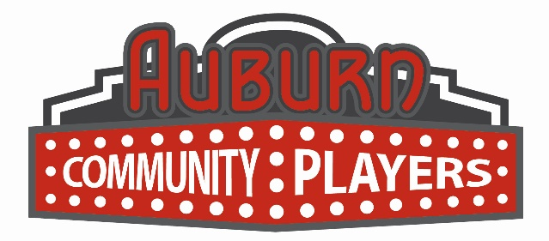
Press Release
For more information or to arrange press passes, please contact:
Auburn Community Players
10 Auburn Avenue Auburn, WA 98002 (253) 833-5678
Jim Kleinbeck, Theater Operations Coordinator
acprockyhorror@gmail.com

FOR IMMEDIATE RELEASE End Date: November 1, 2019
AUBURN COMMUNITY PLAYERS PRESENT
THE ROCKY HORROR SHOW

Auburn, WA- The Auburn Community Players invite you to dance the Time Warp as they present the cult classic, The Rocky Horror Show! This production is directed by Chris Serface, musically directed by Jeff Bell, choreographed by Melanie Gladstone, and assistant directed by Mauro Bozzo.

“It’s astounding; Time is fleeting”…so don’t miss this cult classic! Through elaborate dances and rock songs you’ll meet sweethearts Brad and Janet who are stuck with a flat tire during a storm, and discover the eerie mansion of scientist Dr. Frank-N-Furter. As their innocence is lost, Brad and Janet meet a houseful of wild characters, including a rocking biker and a creepy butler. “With a bit of a mind flip; You're into the time slip; And nothing can ever be the same…”!
Auburn Community Players’ production of The Rocky Horror Show features: Jordan Melin (Dr. Frank-N-Furter), Duncan McManus (The Narrator), Hunter Roy (Brad Majors), Cami Werden (Janet Weiss), Alan Plaster (Riff Raff), Brynne Geiszler (Magenta), Jennifer Torrence (Columbia), Ton Williams (Eddie/Dr.Scott), and Derek Mesford (Rocky); with Aria Nikkhoui, Ariana Skallerud, Alex Chopyak, Andrey Psyche, Cara Hazzard, Chelsea Pedro, Ra’Shawndra Doby, and Christine Choate as Phantoms.

The Rocky Horror Show will run Friday, October 11, 2019 until Thursday, October 31, 2019. Friday & Saturday showings are at 7:00pm. Special performances have been added for Sunday, October 13 at 2:00pm, Saturday, October 19 at 11:00pm, and Thursday, October 31 at 7:00pm. This show is recommended for 16 and up.

Tickets are $17.00 (Adults) & $14.00 (Seniors/Students) presale, or $22.00 (Adults) & $19.00 (Seniors/Students) at the door. Tickets may be purchased online at https://app.arts-people.com/index.php?show=104832, or by calling our Box Office at (253) 931.3043. Audience participation kits will be available for purchase at the performance. There will be no outside participation items allowed in the auditorium.

All performances are held at the Auburn Avenue Theater, 10 Auburn Avenue, Auburn, WA 98002.

###

