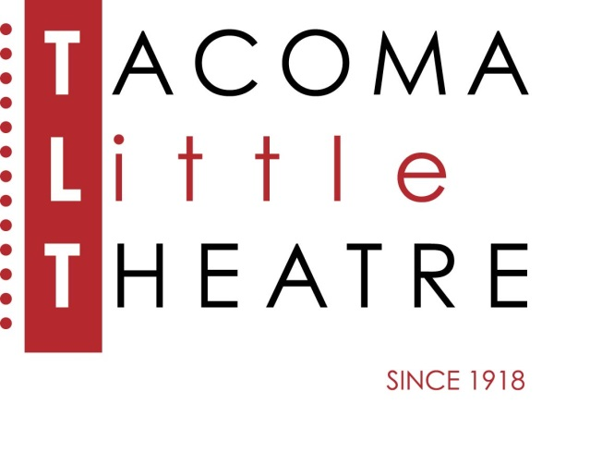
Press Release
210 North I Street, Tacoma, WA 98403 253-272-2281 www.tacomalittletheatre.com
For more information please contact:
Chris Serface, Managing Artistic Director
tlt@tacomalittletheatre.com

FOR IMMEDIATE RELEASE End Date: October 31, 2019

Tacoma Little Theatre’S ‘OFF THE SHELF’ presents
FUDDY MEERS

Tacoma, WA- Tacoma Little Theatre's Off the Shelf program is excited to present David Lindsay-Abaire’s crazy comedy, Fuddy Meers, directed by Suzy Willhoft and featuring some of the Pacific Northwest’s finest actors. This production will play Wednesday, October 30, 2019 at 7:30pm.

Claire has a rare form of psychogenic amnesia that erases her memory whenever she goes to sleep. This morning, like all mornings, she wakes up a blank slate. Her chipper husband comes in with a cup of coffee, explains her condition, hands her a book filled with all sorts of essential information, and he disappears into the shower. A limping, lisping, half-blind, half-deaf man in a ski mask, pops out from under her bed and claims to be her brother, there to save her. Claire's info book is quickly discarded, and she's hustled off to the country-house of her mother, a recent stroke victim whose speech has been reduced to utter gibberish. Claire's journey gets even more complicated when a dimwitted thug with a foul-mouthed hand puppet pops up at a window, and her driven husband and perpetually stoned son show up with a claustrophobic lady-cop that they've kidnapped. Every twist and turn in this funhouse plot bring Claire closer to revealing her past life and everything she thought she'd forgotten. It's one harrowing and hilarious turn after another on this roller coaster ride through the day of an amnesiac trying to decipher her fractured life. This poignant and brutal comedy traces one woman's attempt to regain her memory while surrounded by a curio-cabinet of alarmingly bizarre characters.

Fuddy Meers features the talents of: Claire Garcia, Annette Hockman, Ashley MacPhail, Luke Amundson, Mark Peterson, Chris Serface, and Charlie Stevens.

Tickets for the October 30, 2019 performance at 7:30pm are $10.00 for non TLT Members, and FREE for those who are members. Tickets may be purchased online at www.tacomalittletheatre.com, or by calling our Box Office at (253) 272-2281.

TLT's OFF THE SHELF
We know that there is a tremendous amount of wonderful theatre that deserves to be heard but sometimes just doesn’t get an opportunity. With “Off the Shelf”, local directors and actors will be bringing some scripts to life that we hope you will find entertaining, challenging and educational to our stage. We hope that you’ll sit back and enjoy an evening of theatre. You never know, you might see one of these shows on our mainstage in the future.
###

