PUGET SOUND POETRY CONNECTION
DISTINGUISHED WRITER SERIES

FRIDAY NOVEMBER 8
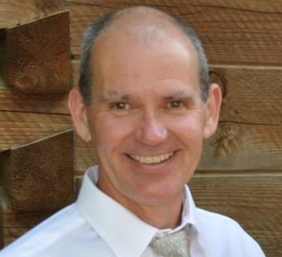
FEATURED READER – BOB TOOHEY

Bob Toohey is a poet, essayist, and blogger (Falling Forward – Into the Hidden Ground of Life) living in Federal Way, WA. Bob is married with five children and six grandchildren.
A graduate from the University of Alabama with majors in both English and Biology, Bob has won the “Write On the Sound” regional writing contest for both poetry and essay, and his poetry has been selected for inclusion in the WA 129 anthology.
Bob has been a featured poet in regional poetry open mic groups.
Bob is regular spiritual retreat facilitator, a national featured speaker for employee workplace safety, and is an avid mountaineer and long-distance runner. Bob was a finisher in the 2019 running of the Boston Marathon.

Reading at Immanuel Presbyterian
901 N J Street Tacoma WA 98103
Doors open at 7 PM
Reading in Basement Fellowship Room – Enter from Parking Lot

Open mic follows the featured reader. All are welcome to sign up.

