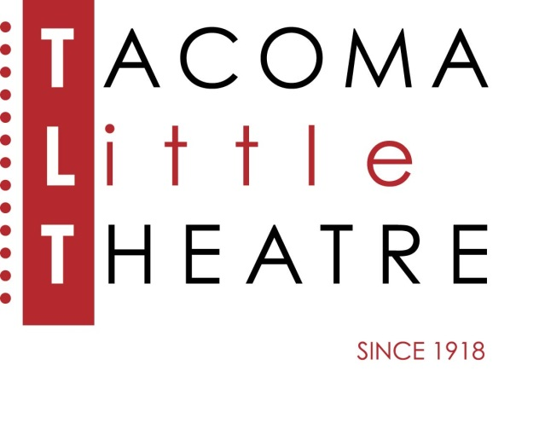
Press Release
210 North I Street, Tacoma, WA 98403 253-272-2281 www.tacomalittletheatre.com
For more information please contact:
Chris Serface, Managing Artistic Director
tlt@tacomalittletheatre.com

FOR IMMEDIATE RELEASE End Date: August 2, 2021
TACOMA LITTLE THEATRE ANNOUNCES
ADULT AND YOUTH IN-PERSON SUMMER CLASSES
JUNE 21-AUGUST 2

Tacoma, WA- TLT is excited to be resuming in-person classes for Summer! To enroll visit https://www.tacomalittletheatre.com/current-classes. For questions please call 253.272.2281 or email education@tacomalittletheatre.com.

ADULT AUDITION WORKSHOP (AGES 18 & UP)
JUNE 21-AUGUST 2
CLASSES: TUESDAYS 6:00PM-8:00PM
TUITION: $150.00
INSTRUCTED BY: RICK HORNOR
We are excited to get our Adult in-person classes going again with this program. As theatres are preparing to open up and start shows again, actors are brushing up their audition pieces and skills. This course will help you get prepared and ready to take on the audition and callback process for upcoming shows! Roughly half of the class will be focused on individual monologues and the second half will be focused on cold reads/on the spot scene work that comes with callbacks! This course will be taught by Rick Hornor, former professor at Whitworth University.
PLEASE NOTE: In-person students will be required to wear masks at this time.
If you would prefer to remain remote we are offering in-person and Zoom. So you will join class either in person or online.

THE LION KING DANCE CLASS (ALL AGES)
JUNE 21-25
CLASSES: MONDAY-FRIDAY 4:30PM-5:30PM*
TUITION: $150.00
INSTRUCTED BY: MELANIE GLADSTONE
We are so excited to offer in-person or remote dance classes this summer! If you feel up for it, you can come join Melanie in-person for a masked and socially distant Disney dance week! This week you will work on choreography for a song from Lion King. If you would prefer to stay at home, Melanie will have a computer set up so you can still watch her and participate, or watch the recordings. Recordings will be made available to all students!
PLEASE NOTE: In-person students will be required to wear masks at this time.
If your student is in the daytime camp, they may stay after and wait for the start of dance class.

MARY POPPINS DANCE CLASS (ALL AGES)
JULY 12-16
CLASSES: MONDAY-FRIDAY 4:30PM-5:30PM*
TUITION: $150.00
INSTRUCTED BY: MELANIE GLADSTONE
We are so excited to offer in-person or remote dance classes this summer! If you feel up for it, you can come join Melanie in-person for a masked and socially distant Disney dance week! This week you will work on choreography for a song from Mary Poppins. If you would prefer to stay at home, Melanie will have a computer set up so you can still watch her and participate, or watch the recordings. Recordings will be made available to all students!
PLEASE NOTE: In-person students will be required to wear masks at this time.
If your student is in the daytime camp, they may stay after and wait for the start of dance class.

STAGE MANAGEMENT TRAINING (ADULTS AND TEENS 14 & OLDER)
JULY 19-23
CLASSES: MONDAY-FRIDAY 6:00PM-8:00PM*
TUITION: FREE
INSTRUCTED BY: NENA CURLEY
Have you been thinking about giving stage management a try, or maybe done it and wished you had some better tools for the next time you do it? Or do you just want to learn more about this area of theatre? Well sign up for this FREE workshop! Adult students will have the opprotunity to apply for work with Tacoma Little Theatre's upcoming 2021/2022 season, 14-18 year-olds can also apply, however, will only be considered to Assistant Stage Manager or help with spot/sound board operation.
This workshop will be run by Nena Curley, TLT's Production and Education Manager. Nena has been stage managing for 15 years, studied stage management in college and been the resident Stage Manager at TLT for the past 4 years.
This workshop will be offered in person and via Zoom.
FROZEN DANCE CLASS (ALL AGES)
JULY 19-23
CLASSES: MONDAY-FRIDAY 4:30PM-5:30PM*
TUITION: $150.00
INSTRUCTED BY: MELANIE GLADSTONE
We are so excited to offer in-person or remote dance classes this summer! If you feel up for it, you can come join Melanie in-person for a masked and socially distant Disney dance week! This week you will work on choreography for a song from Frozen. If you would prefer to stay at home, Melanie will have a computer set up so you can still watch her and participate, or watch the recordings. Recordings will be made available to all students!
PLEASE NOTE: In-person students will be required to wear masks at this time.
If your student is in the daytime camp, they may stay after and wait for the start of dance class.

BEAUTY AND THE BEAST DANCE CLASS (ALL AGES)
JULY 26-30
CLASSES: MONDAY-FRIDAY 4:30PM-5:30PM*
TUITION: $150.00
INSTRUCTED BY: MELANIE GLADSTONE
We are so excited to offer in-person or remote dance classes this summer! If you feel up for it, you can come join Melanie in-person for a masked and socially distant Disney dance week! This week you will work on choreography for a song from Beauty and the Beast. If you would prefer to stay at home, Melanie will have a computer set up so you can still watch her and participate, or watch the recordings. Recordings will be made available to all students!
PLEASE NOTE: In-person students will be required to wear masks at this time.
If your student is in the daytime camp, they may stay after and wait for the start of dance class.
###

