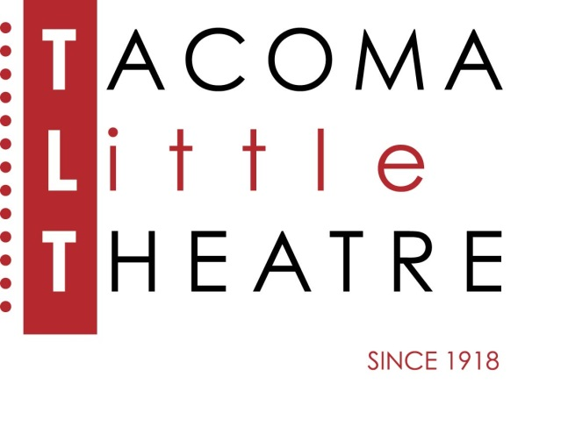
Press Release
210 North I Street, Tacoma, WA 98403 253-272-2281 www.tacomalittletheatre.com
For more information please contact:
Chris Serface, Managing Artistic Director
tlt@tacomalittletheatre.com

FOR IMMEDIATE RELEASE End Date: August 15, 2021
AUDITIONS: THE WIZARD OF OZ
AUGUST 9th & AUGUST 10TH
Tacoma, WA- Tacoma Little Theatre is holding auditions for its holiday production of the family classic, The Wizard of OZ, based on the L. Frank Baum novel and MGM film. The Wizard of OZ will be directed and choreographed by Andrew Coopman with musical direction by Jeff Bell.

Auditions will be held Monday, August 9th and Tuesday, August 10th at Tacoma Little Theatre. Audition appointments will be set between the times of 7:00pm-10:00pm on Monday and 7:00pm-10:00pm on Tuesday in five-minute increments. Callbacks will be held on Wednesday, August 11th.

Click your heels together as you experience one of the most famous stories of all time come to life on our stage. The Wizard of OZ has been enchanting families for generations. Follow the yellow brick road and join Dorothy, her little dog Toto, the Scarecrow, Tin Man, and Lion as they journey over the rainbow to the merry old land of Oz in search of the great and powerful Wizard. Will he grant them their hearts’ desires? With all your favorite songs, including “We’re Off to See the Wizard,” “If I Only had a Brain,” and “Somewhere Over the Rainbow,” this timeless musical will sweep you into a magical holiday adventure.

Auditioners are asked to prepare a 32-bar cut from two contrasting songs that show off your vocal technique. We may only ask for one, but have both ready. An accompanist is provided, so please bring sheet music clearly marked and in the correct key.

Actors of all ethnicities and gender identities are encouraged to audition and all roles are available. We will only be casting adults and youth over the age of 12 for this production. Dorothy (female, teens-20s), Aunt Em/Glinda (female, 30s-50s), Hunk/Scarecrow (male, 30s-40s), Hickory/Tin Man (male, 30s-40s), Zeke/Cowardly Lion (male, 30s-40s), Miss Gulch/Wicked Witch (female, 30s-50s), Professor Marvel/OZ (male, 30s-60s), Uncle Henry/Guard (male 30s-50s), Male and Female ensemble roles to play Munchkins, Flying Monkeys, OZians, Winkies, Poppies, Trees, Crows, and more (ages 12-adult). Ages given are playable ages, actors need not specifically fit the given age to audition.

TLT will require all staff and performers to show proof of having had a COVID-19 vaccination. For those who decline vaccination, or are not eligible, a negative COVID test (frequency per CDC guidance) will be required. These requirements will be in effect from auditions through the end of each particular show.

To reserve an audition time, follow this link (http://castingmanager.com/audition/info/n6yMTuBAWZ9YwLv), or call our Box Office for assistance at (253) 272-2281.

Once cast, The Wizard of OZ will run from Friday, December 10, 2021 to Friday, December 31, 2021.
###

