For 4 items below Contact Roxanne Burns at Rox@RoxanneBurns.com

Fabric stretcher bars, Arty’s Easy Fix , brand new
$35
A BARGAIN! Brand new, you get what is in pictures, carrying bag has small damage hole but does not affect storage. See picture. Stretches fabrics like silk or cotton so you can paint your artwork on them. Custom scarves, quilt blocks, etc.

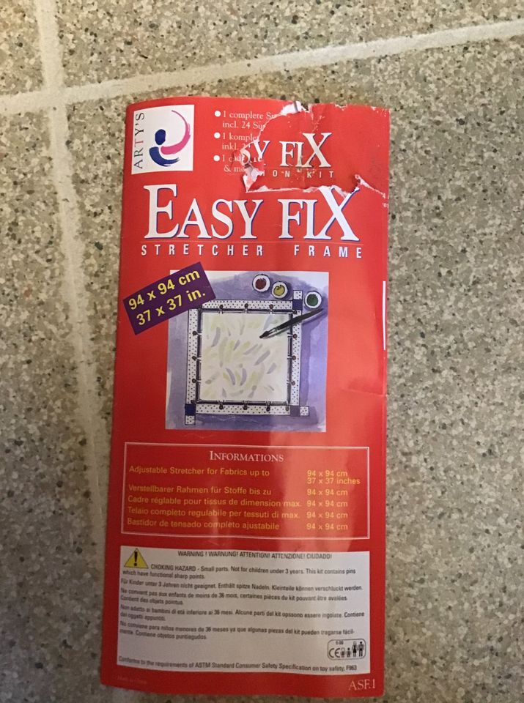

Alto’s Mat Cutting System , model 4501
$35
Approx 31 inches long Alto’s mat cutting system, model 4501. Bought it used but never used it. Cut your own mats for a fraction of the price. You get what you see in pictures
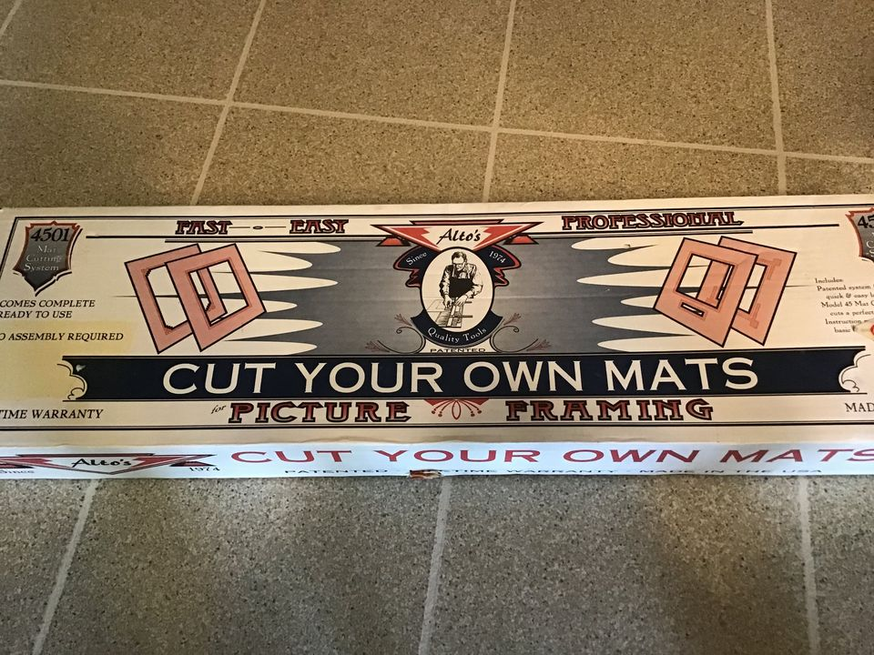

Professional photography lighting lights Interfit Prolite 9 , set of 2 with stands
$200
Brand is Interfit Prolite 9, as in 9 bulbs in each light. This is set of 2 lights and 2 stands. Stands have carrying bags. Lights can light up in various patterns depending on how much light you want. Notice switches on back of light giving you different bulb combinations. Both have plexiglass diffusers. Only one light is shown is pictures but THIS IS A SET OF 2 of each item. One light has 2 bulbs that need replacing. Reasonable offers considered. Need to move them out.
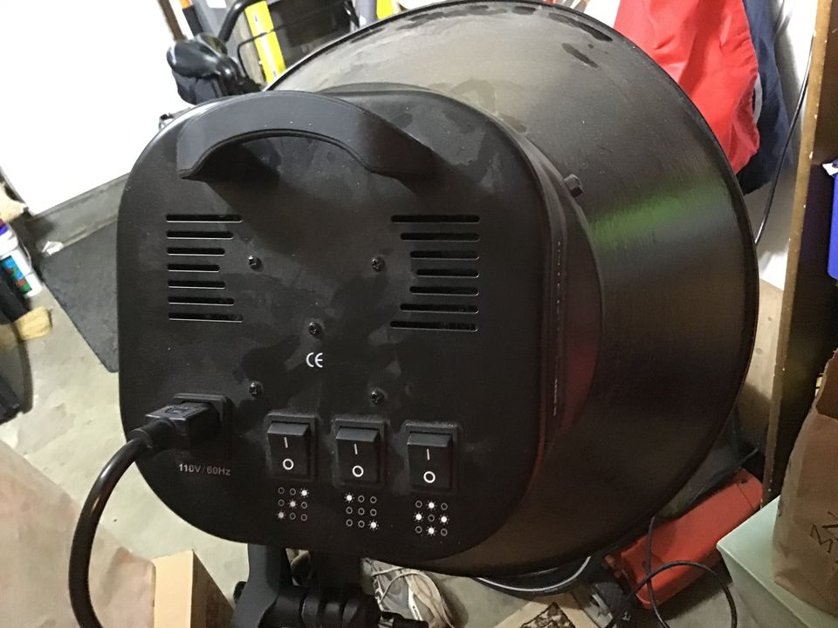

Portable tabletop Large Art artist Illustrator Drafting/Drawing Board Mayline
$30
42 x 30 inches. Large Drafting Drawing board. As seen in pictures. Padded handle. Portable drawing and art surface. Small legs on back fold up and down to tilt board while you work, reducing fatigue.

