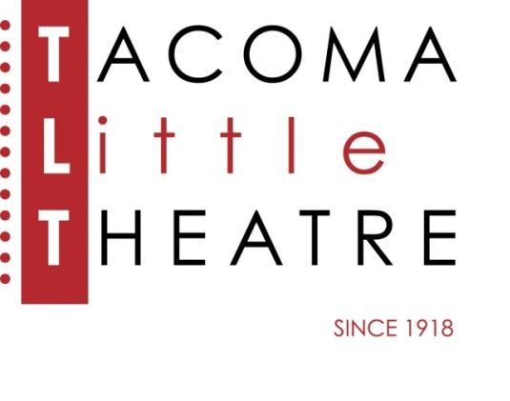
Press Release
210 North I Street, Tacoma, WA 98403 253-272-2281 www.tacomalittletheatre.com
For more information please contact:
Chris Serface, Managing Artistic Director
tlt@tacomalittletheatre.com

FOR IMMEDIATE RELEASE End Date: December 21, 2021

Tacoma Little Theatre ANNOUCES
THE WIZARD OF OZ-WINTER BREAK CAMP
Tacoma, WA-Tacoma Little Theatre is excited to announce enrollment for its Winter Break camp production of The Wizard of OZ, directed by Rico Lastrapes and musically directed by Jeff Bell.

Journey with us away from Kansas for this exciting musical! While the main stage holiday production is Wizard of Oz, we are excited to give our young performers a chance at a similar production! Help Dorothy, Scarecrow, Tinman and Lion defeat the Wicked Witch and gain their greatest rewards! Includes all your favorite songs like: Somewhere Over the Rainbow, Ding Dong The Witch Is Dead, and If I Only Had A Brain.

Rehearsals will be December 20-23 & December 27-30 from 9:00am-4:00pm, and December 30 from 9:00am-12:00pm. Performances will be January 1 & 2 at 2:00pm. Students in grades 1-12 are able to enroll, and all rehearsals/performances will take place at Tacoma Little Theatre.

Tuition is $350.00 and some financial aid is available. For more details and to enroll visit www.tacomalittletheatre.com, or call our Box Office at (253) 272-2281.

###

