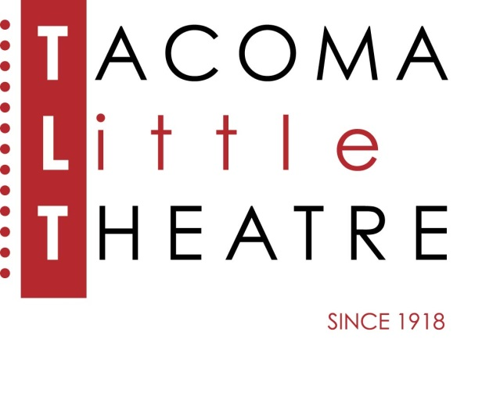
Press Release
210 North I Street, Tacoma, WA 98403 253-272-2281 www.tacomalittletheatre.com
For more information please contact:
Chris Serface, Managing Artistic Director
tlt@tacomalittletheatre.com

FOR IMMEDIATE RELEASE End Date: May 16, 2022
TACOMA LITTLE THEATRE PRESENTS
THE HAPPIEST SONG PLAYS LAST

Tacoma, WA- Tacoma Little Theatre in partnership with University of Washington-Tacoma and Toy Boat Theatre, present The Happiest Song Plays Last, by Quiara Alegría Hudes, and directed by Marilyn Bennett.

In a barrio living room in North Philly, an activist-turned-music-professor moonlights as the local soup kitchen queen, cooking free rice and beans for any hungry neighbor. Halfway around the world, her cousin relives his military trauma on the set of a docudrama that’s filming in Jordan. With the Egyptian revolution booming in the distance, these two young adults try to sing a defiant song of legacy and love in the face of local and global unrest.

Tacoma Little Theatre’s production of The Happiest Song Plays Last features Maria-Tania Bandes B. Weingarden as Yaz, Katie Jones as Shar, Jesús Villegas as Agustin, Wade Hicks as Lefty, Terence Mejos as Elliot, and Shailendra P. Jain as Ali. Live on-stage music will be provided by Anand Landon and Storm Tucker.

The Happiest Song Plays Last will run Friday, April 29, 2022, through Sunday, May 15, 2022. Friday and Saturday showings are at 7:30pm and Sundays at 2:00pm. The Happiest Song Plays Last is recommended for ages 12 and up. There will be an ASL interpreted performance on Sunday, May 15, 2022 at 2:00pm.

Tickets are $27.00 (Adults), $25.00 (Seniors 60+/Students/Military), and $20.00 (Children 12 and under). Tickets may be purchased online at www.tacomalittletheatre.com, or by calling our Box Office at (253) 272-2281. Group rates are available for 10 or more, and special FLEX passes for 6 are only $145.00. TLT currently requires proof of COVID-19 vaccination at the door for all audience members and masks will also be required while inside the building. For our most up-to-date COVID-19 protocols please visit www.tacomalittletheatre.com/covid.

There will be a special “Pay What You Can” performance on Thursday, May 12, 2022. Tickets for that performance are only available in person or over the phone.

###

