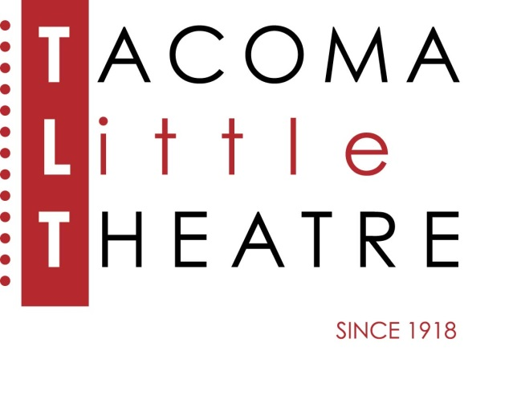
Press Release
210 North I Street, Tacoma, WA 98403 253-272-2281 www.tacomalittletheatre.com
For more information please contact:
Chris Serface, Managing Artistic Director
tlt@tacomalittletheatre.com

FOR IMMEDIATE RELEASE End Date: June 20, 2022
TACOMA LITTLE THEATRE PRESENTS
THE LUCK OF THE IRISH

Tacoma, WA- Tacoma Little Theatre presents as part of its 103rd Season, The Luck of the Irish, by Kirsten Greenidge, and directed by Lydia K. Valentine, Tacoma’s Poet Laureate.

In the words of playwright Kirsten Greenidge, The Luck of the Irish is “...a glass prism: all slants and angles surrounding… different configurations of characters grappling with the dreams and hopes and choices that were made with all the greatest intentions half a century earlier.” It explores the American experience with its multifaceted and layered complexities, both past and present.

The Taylors, a wealthy Black American couple, plan to buy a home in an all White neighborhood in 1950s Boston, and—to avoid being the target of arson again—they pay the Donovans, a struggling Irish American couple, to "ghost-buy" a house on their behalf. Fifty years later, the Donovans confront the Taylor heirs in an effort to get “their” house back.

Moving across two eras, The Luck of the Irish considers the immunity endowed by social privilege of class, race, or gender; the pitfalls of assumed entitlement; and the universal longing for home.

Tacoma Little Theatre’s production of The Luck of the Irish features Laurice Roberts as Lucy Taylor, Mark Peterson as Rex Taylor, Janice Williams as Hannah Davis, Joshua Davis as Rich Davis, Amy Van Mechelen as Nessa Charles, Jason Sharp as Joe Donovan, Jill Heinecke as Patty Ann Donovan, Joseph Grant as Mr. Donovan, Debbie Birkey as Mrs. Donovan, and William Taibleson as Miles.

The Luck of the Irish will run Friday, June 3, 2022, through Sunday, June 19, 2022. Friday and Saturday showings are at 7:30pm and Sundays at 2:00pm. The Luck of the Irish is recommended for ages 12 and up. There will be an ASL interpreted performance on Sunday, June 19, 2022 at 2:00pm.

Tickets are $27.00 (Adults), $25.00 (Seniors 60+/Students/Military), and $20.00 (Children 12 and under). Tickets may be purchased online at www.tacomalittletheatre.com, or by calling our Box Office at (253) 272-2281. Group rates are available for 10 or more, and special FLEX passes for 6 are only $145.00. TLT currently requires proof of COVID-19 vaccination at the door for all audience members and masks will also be required while inside the building. For our most up-to-date COVID-19 protocols please visit www.tacomalittletheatre.com/covid.

There will be a special “Pay What You Can” performance on Thursday, June 16, 2022. Tickets for that performance are only available in person or over the phone.

