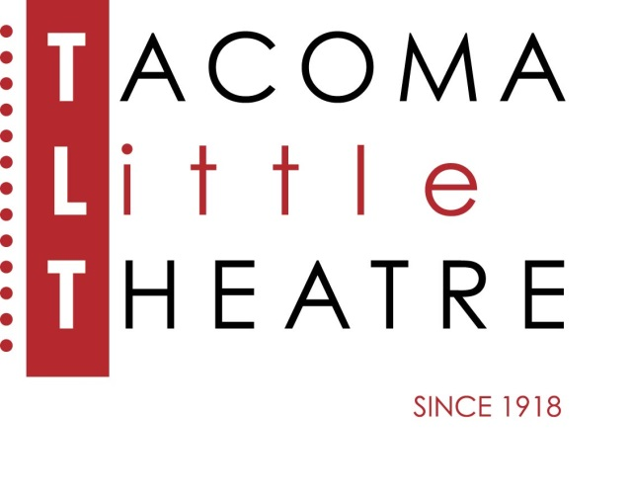
PRESS RELEASE
210 North I Street, Tacoma, WA 98403 253-272-2281 www.tacomalittletheatre.com
For more information please contact:
Chris Serface, Managing Artistic Director
tlt@tacomalittletheatre.com

FOR IMMEDIATE RELEASE End Date: November 7, 2022
TACOMA LITTLE THEATRE PRESENTS
MURDER ON THE ORIENT EXPRESS

Tacoma, WA- Just in time for Fall, Tacoma Little Theatre presents Agatha Christie’s Murder on the Orient Express, adapted for the stage by Ken Ludwig (Lend Me A Tenor, Holmes for the Holidays). This thrilling new version of the classic mystery will be directed by Melanie Gladstone.

Board the exotic and mysterious Orient Express as it takes off into the opulence and grandeur of the 1930s. Just after midnight, a snowdrift stops the Orient Express in its tracks. The luxurious train is surprisingly full for the time of year, but by the morning, it is one passenger fewer. An American tycoon lies dead in his compartment, his door locked from the inside. Isolated and with a killer in their midst, the passengers rely on detective Hercule Poirot to identify the murderer – in case they decide to strike again. Join Poirot as he battles the clock to figure out “whodunit” in this sleek, stylish, and surprisingly comedic murder mystery.

Tacoma Little Theatre’s production of Murder on the Orient Express features Craig Rock as Hercule Poirot, Jacob Tice as Monsieur Bouc, Andrea Gordon as Mary Debenham, Ton Williams as Hector Macqueen, Alan Plaster as Michel the Conductor, Rosalie Hilburn as Princess Dragomiroff, Marissa-Clare Hissey as Greta Ohlsson, Canae Gray as Countess Andrenyi, Jenifer Gillis Rifenbery as Helen Hubbard, Brandon Fair as Colonel Arbuthnot, Josh Johnson as Samuel Ratchett (Understudy Poirot/Michel/Colonel), Josie DeRosier as Head Waiter (Understudy Macqueen/Bouc), Haylee Welsh as Understudy Princess/Helen, and Jean-Michele Gregory as Understudy Greta/Countess/Mary.

Murder on the Orient Express will run Friday, October 21, through Sunday, November 6, 2022. Friday and Saturday showings are at 7:30pm and Sundays at 2:00pm. The performance on Sunday, November 6, 2022, at 2:00pm will be an ASL interpreted performance.

Tickets are $27.00 (Adults), $25.00 (Seniors 60+/Students/Military), and $20.00 (Children 12 and under). Tickets may be purchased online at www.tacomalittletheatre.com, or by calling our Box Office at (253) 272-2281. Group rates are available for 10 or more, and special FLEX passes for 6 are only $145.00. Masks are required while attending a production at Tacoma Little Theatre. For our full COVID-19 protocols please visit www.tacomalittletheatre.com/covid.

There will be a special “Pay What You Can” performance on Thursday, November 3, 2022 at 7:30pm. Tickets for that performance are available in advance online, in person, or over the phone.

Murder on the Orient Express is recommended for ages 12 and up.

###

