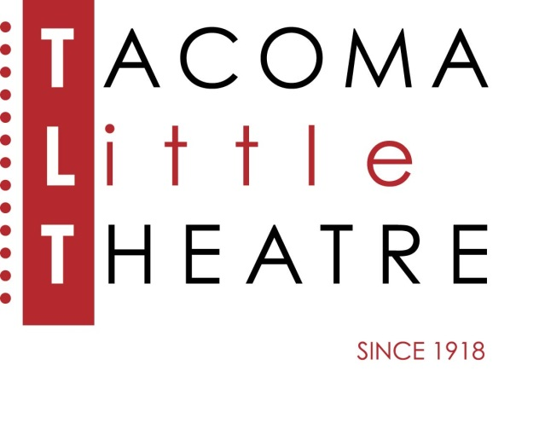
PRESS RELEASE
210 North I Street, Tacoma, WA 98403 253-272-2281 www.tacomalittletheatre.com
For more information please contact:
Chris Serface, Managing Artistic Director
tlt@tacomalittletheatre.com

FOR IMMEDIATE RELEASE End Date: June 19, 2023
TACOMA LITTLE THEATRE PRESENTS
THE SHAWSHANK REMDEMPTION

Tacoma, WA-Tacoma Little Theatre closes its 104th Season with The Shawshank Redemption, by Owen O’Neill & Dave Johns. This powerful and moving story will be directed by Blake R. York.

Based on the novella by Stephen King, this adaptation of The Shawshank Redemption hearkens to the 1994 critically acclaimed film, bringing audiences to the edge of their seats. Andy Dufresne is convicted of the murder of his wife and her lover and sentenced to life imprisonment at Shawshank prison. While at Shawshank, Andy befriends some of the other inmates, namely a character known as Red. Over time Andy finds a way to live out life with as much relative ease as one can find in prison, leaving a message for all that while the body may be locked away in a cell, the spirit can never be truly imprisoned.

Tacoma Little Theatre’s production of The Shawshank Redemption features Mason Quinn as Andy, Mark Peterson as Red, Joseph Grant as Warden Stammas, Joshua Johnson as Hadley, Alex Vowles as Entwistle, Darius Sakui as Tommy Williams, Beau Prichard as Dawkins, Ton Williams as Rico, Roger Iverson as Brooksie, Joshua Olver as Bogs Diamond, Paul Richter as Rooster, Jeffrey York as Pinky, and Nathan Lovitt, Glenn Fischer & Russ Coffey as Ensemble.

The Shawshank Redemption will run Friday, June 2, through Sunday, June 18, 2023, for a total of 10 performances. Friday and Saturday showings are at 7:30pm and Sundays at 2:00pm.

The performance on Sunday, June 18, 2023, at 2:00pm will be an ASL interpreted performance.

Tickets are $27.00 (Adults), $25.00 (Seniors 60+/Students/Military), and $20.00 (Children 12 and under). Tickets may be purchased online at www.tacomalittletheatre.com, or by calling our Box Office at (253) 272-2281. Group rates are available for 10 or more, and special FLEX passes for 6 are only $145.00. TLT strongly recommends, but does not require, that patrons wear masks and are vaccinated.

There will be a special “Pay What You Can” performance on Thursday, June 15, 2023, at 7:30pm. Tickets for that performance are available now online, in person, or over the phone.

The Shawshank Redemption is recommended for ages 16 and over and contains strong language, mature subject matter, and depictions of violence and rape.

###

