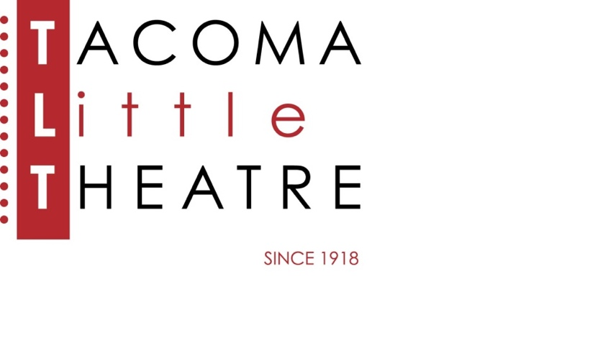

Press Release

210 North I Street, Tacoma, WA 98403    **253-272-2281**    [www.tacomalittletheatre.com](http://www.tacomalittletheatre.com)

For more information please contact:

**Chris Serface, Managing Artistic Director**

[tlt@tacomalittletheatre.com](mailto:tlt@tacomalittletheatre.com)

**FOR IMMEDIATE RELEASE** End Date: **September 20, 2023**

**AUDITIONS: RUDOLPH THE RED-NOSED REINDEER  
SEPTEMBER 17TH THROUGH SEPTEMBER 19TH**

*Tacoma, WA*-Tacoma Little Theatre is holding auditions for its production of the holiday classic, *RUDOLPH THE RED-NOSED REINDEER*. This production will be directed by Nick Fitzgerald, with musical direction by Debra Leach, and choreography by Melanie Gladstone.

Auditions will be held Sunday, September 17th and Monday, September 18th at Tacoma Little Theatre (210 N I Street, Tacoma WA 98403) and on Tuesday, September 19th at STAR Center (3873 S 66th St, Tacoma, WA 98409). Audition appointments will be set starting at 6:00pm on Sunday and 7:00pm on Monday & Tuesday in five-minute increments. Callbacks will be held on Wednesday, September 20th at Tacoma Little Theatre. All actors must schedule their appointment using Casting Manager at the link below.

The holiday classic soars off the screen in this musical adaptation of the beloved television special. Filled with holiday hits like “Rudolph the Red-Nosed Reindeer” and “A Holly Jolly Christmas,” *Rudolph the Red-Nosed Reindeer™* features all of your favorite characters including Santa and Mrs. Claus, Hermey the Elf, Bumble the Abominable Snow Monster, Clarice, Yukon Cornelius and, of course, Rudolph. It’s an adventure that teaches us that what makes you different can be what makes you special.

Tacoma Little Theatre encourages performers of all racial and ethnic backgrounds, gender identities and expressions, and performers living with disabilities to audition.

Auditioners are asked to prepare 32 bars of your favorite Holiday song, or any song that shows off your voice and talent. Please bring sheet music in the correct key. An accompanist will be provided.

All roles are available:

SAM, SANTA CLAUS, MRS. CLAUS, DONNER, MRS. DONNER, RUDOLPH, HERMEY, BOSS ELF, FIREBALL, COACH COMET, CLARICE, YUKON CORNELIUS, BUMBLE, KING MOONRACER, CLARICE’S FATHER, OTHER REINDEER, MISFIT TOYS, ELVES, & YOUTH CHORUS. Many roles will be double-cast as needed. Youth auditioning for the show need to be over the age of 10. For full casting details, visit the audition site.

All actors cast receive a travel reimbursement up to $150.00.

To reserve an audition time, follow this link (<http://castingmanager.com/audition/info/MKQJYcVXTk1kmyd>) or call our Box Office for assistance at (253) 272-2281.

Once cast, *Rudolph the Red-Nosed Reindeer* will begin rehearsing on October 9, 2023. The production will run from Friday, December 8, 2023 to Sunday, December 31, 2023.

**###**