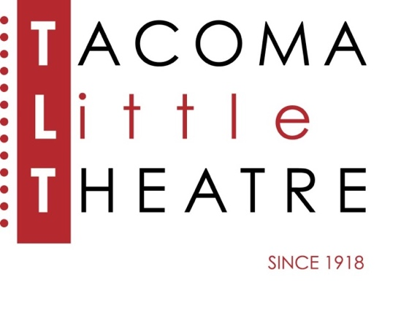
Press Release
210 North I Street, Tacoma, WA 98403 253-272-2281 www.tacomalittletheatre.com
For more information please contact:
Chris Serface, Managing Artistic Director
tlt@tacomalittletheatre.com

FOR IMMEDIATE RELEASE End Date: April 30, 2024
AUDITIONS: ONE MAN, TWO GUVNORS
APRIL 28-29, 2024
Tacoma, WA-Tacoma Little Theatre is holding auditions for the first show of its 2024/2025 season, the hilarious British comedy, One Man, Two Guvnors. This production will be directed by Brett Carr.

Auditions will be held Sunday, April 28th and Monday, April 29th at Tacoma Little Theatre (210 N I Street, Tacoma WA 98403). Audition appointments will be set starting at 6:00pm on Sunday and 7:00pm on Monday. Callbacks will be held on Thursday, May 2nd at Tacoma Arts Live. All actors must schedule their appointment using Casting Manager at the link below.

Brighton, England. 1963. Change is in the air, and Francis Henshall is looking to make his mark. Fired from a skiffle band and in search of work, he finds himself employed by small-time gangster Roscoe Crabbe. But Roscoe is really Rachel, posing as her own dead brother, herself in love with Stanley Stubbers who, in turn, becomes our hero’s other 'guvnor'. Fighting a mounting sense of confusion, Francis goes out of his way to serve both bosses. But with the distractions of a feminist book keeper, a self-important actor, and select members of the criminal fraternity (not to mention his own mammoth appetite) to contend with, how long can he keep them apart? Richard Bean’s hilarious comedy received 5-star reviews from every London newspaper and was the hit of the 2012 Broadway season.

Tacoma Little Theatre encourages performers of all racial and ethnic backgrounds, gender identities and expressions, and performers living with disabilities to audition. Roles available are: Stanley Stubbers (male identifying, 20s-30s), Rachel Crabbe (female identifying, 20s-30s), Harry Dangle (male identifying, 40s-60s), Charlie Clench (male identifying, 50s-60s), Lloyd Boateng (male identifying, 30s-50s), Pauline Clench (female identifying, 20s-30s), Alan Dangle (male identifying, 20s-30s), Dolly (female identifying, 20s-40s), Alfie (male identifying, 18 and up), Gareth (male identifying, 18 and up), and Ensemble (male and female identifying, 18 and up). The role of Francis Henshall has been already cast.

Auditioners are asked to be familiar with and prepared to read from the monologues and sides provided on Casting Manager (printed copies will be available at the audition). If you desire, you may also prepare a short comedic monologue (no longer than two minutes).

All actors cast receive a travel reimbursement up to $150.00.

To reserve an audition time, follow this link (http://castingmanager.com/audition/info/AMXJ3yazZ31wxbs) or call our Box Office for assistance at (253) 272-2281.

Once cast, One Man, Two Guvnors, will begin rehearsals in July of 2024. The production will run from Friday, September 6, 2024, to Sunday, September 22, 2024.
###

