For Immediate Release

### 

### CONTACT INFORMATION

***Voices of Tacoma: A Gathering of Poets***

Burl E. Battersby

Be! Eugene Be! Creative

[Voices of Tacoma](https://www.beeugenebecreative.com/voicesoftacoma)

beeugenebecreative.com/voicesoftacoma

(206) 406-8838

### RELEASE DATE

September 1, 2024

Launch of *Voices of Tacoma: A Gathering of Poets*

At Tacoma Studio Tour Events

***Voices of Tacoma: A Gathering of Poets*,** an anthology of poetry of, about, or inspired by Tacoma, will be launched at three different Tacoma Public Library branches on Saturday, October 12th.

As part of Tacoma Arts Month Studio Tours, the events will create “Poet’s Studios” at Mottet, South Tacoma, and Fern Hill Libraries. The free and all-ages events will run from 11am to 5pm. Copies of the book will be available for sale and will also be available to check out from the library. Come hear the #VoicesofTacoma Poets read their work!

***Voices of Tacoma*** was partly funded by the Tacoma Artists Initiative Program and includes the work of eighty poets, with one-hundred-twenty-two poems. The book is richly illustrated with the poetic and themed drawings of renowned Tacoma Artist, Mauricio Robalino, who also created the cover art.

It will be available for purchase at all local bookstores, [online](https://shop.ingramspark.com/b/084?kJWWkdPWxGcQ9ze1JqJVrajKngZmhBxMf5ptPy8CbxZ) (available now for pre-order), or will be able to be checked out from your local library branch.

**About the Project**

From the start this has been an equity-focused project with the intention of including all the voices of Tacoma. Community events were held across the City and outreach included partnerships with several local organizations. Despite these efforts, when the first submission period ended in January the racial demographics were overwhelmingly white.

After reopening to BIPOC poets the project received work from a much more diverse population of writers. Better, but not perfect, the Latino population was still under-represented and submissions were not received from a few neighborhoods within greater Tacoma. Future editions of this work will focus on developing deeper connections within these communities.

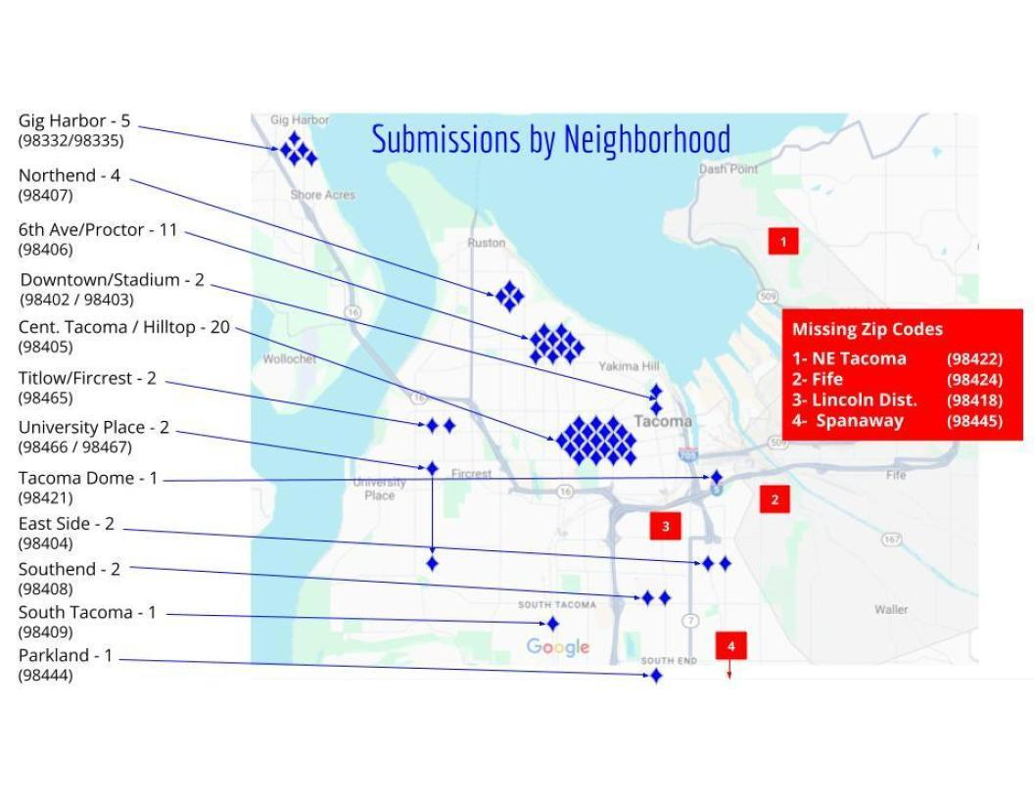

**Project Demographics Results Tacoma 2020 Census**

African American / Black 11% 11%

Asian 10% 9%

Hispanic, Latino, or Spanish 6% 12%

Indigenous or Native American 7% 2%

Native Hawaiian or Pacific Islander 1% 1%

White 40% 57%

Two or or more races 17% 13%

Other 7% 4%

Voices of Tacoma Executive Editor, Burl Battersby (he/him), lives in the South End of Tacoma. He is the Director of Green River College’s Kent Campus and writes poetry, fiction, and essays under the name B. Eugene B.