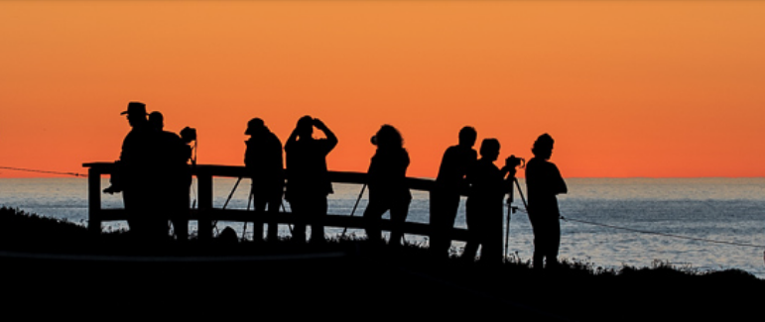**On Seeing Nature – *Through the* *Photographic Lens***

**Featuring**:   
Nature Photographer   
 **Steve Russell**

**&**

Bestselling Author

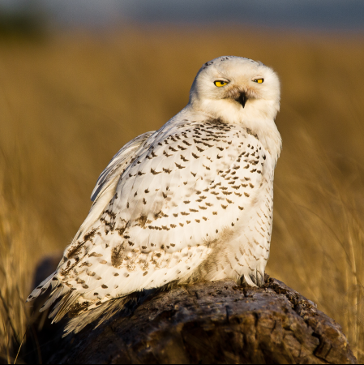**Mark Turner**

**Saturday,   
 September 28**

**9:00-12:30**   
featured speakers +   
panel discussion

**To be held at the   
 UPS Campus – Tacoma**

Panel Discussion professionals include:

* Photographers Belen Schneider + Bill Johnson

**Attendees will learn:**

***How photography hones curiosity, observation skills, and awareness for both the viewer and photographer, creating useful outcomes as we endeavor to sustain and restore vital habitats for birds and pollinators.***

**Registration & Event Details**: https://www.eventbrite.com/e/on-seeing-nature-through-the-photographic-lens-tickets-1002929668637?utm-campaign=social&utm-content=attendeeshare&utm-medium=discovery&utm-term=listing&utm-source=cp&aff=ebdsshcopyurl

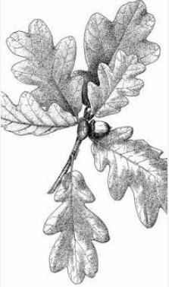**$10 Students; $35 All Others**



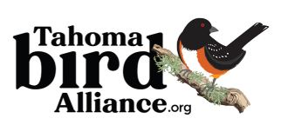 Produced by   
 ***Quercus   
 Collaborative, LLC***

***On Seeing Nature - Day of Event Agenda***

8:15: Access Thompson Hall – Room 175 for Foyer Set-up

8:45: AV Set-up with Ellie (UPS/Museum Natural History rep)

9:00: Introductions:

* Land Acknowledgement + Thanks to Program Sponsors:
  + UPS/Museum Natural History (plug their location)
  + WNPS – Central + SSC
  + Others?
  + Coffee/Others
* Anna’s Program Objectives (past, present, future)
* Overview of facility, speakers

9:15 – 10:15: Steve Russell presentation (includes 10 -15 min of QnA)  
***Bird Photography for Birders: Using Light, Anticipation and Camera Settings to Enhance Your Photos***

10:15 – 10:30: Coffee/Restroom break?

10:30 – 11:30: Mark Turner presentation (includes 10 -15 min of QnA)

11:30 – 11:45: Coffee/Restroom break?

11:45 – 12:30: Panel Discussion

* Steve Russell
* Mark Turner
* Belen Schneider
* Bill Johnson

<https://www.eventbrite.com/e/on-seeing-nature-through-the-photographic-lens-tickets-1002929668637?aff=OSNsponsorTBA>

<https://www.eventbrite.com/e/on-seeing-nature-through-the-photographic-lens-tickets-1002929668637?aff=OSNsponsorWNPS>

<https://www.eventbrite.com/e/on-seeing-nature-through-the-photographic-lens-tickets-1002929668637?aff=OSNsponsorSchools>

<https://www.eventbrite.com/e/on-seeing-nature-through-the-photographic-lens-tickets-1002929668637?aff=OSNturnerPR>

<https://www.eventbrite.com/e/on-seeing-nature-through-the-photographic-lens-tickets-1002929668637?aff=OSNRussellPR>

<https://www.eventbrite.com/e/on-seeing-nature-through-the-photographic-lens-tickets-1002929668637?aff=OSNQuercusPR>

<https://www.eventbrite.com/e/on-seeing-nature-through-the-photographic-lens-tickets-1002929668637?aff=OSNotherPR>

<https://www.eventbrite.com/e/on-seeing-nature-through-the-photographic-lens-tickets-1002929668637?aff=OSNmuseumUPS>

General Share: <https://www.eventbrite.com/e/on-seeing-nature-through-the-photographic-lens-tickets-1002929668637?utm-campaign=social&utm-content=attendeeshare&utm-medium=discovery&utm-term=listing&utm-source=cp&aff=ebdsshcopyurl>