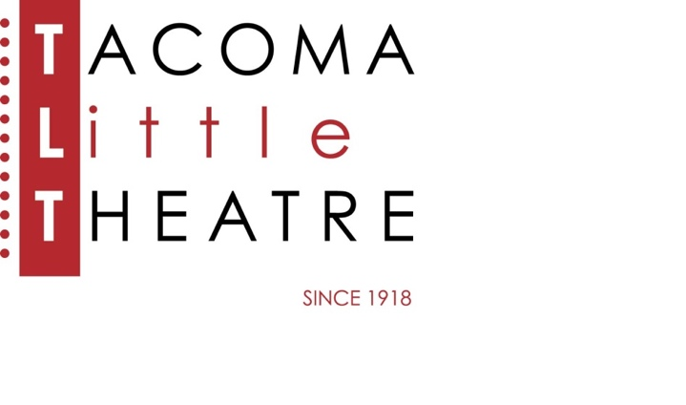

PRESS RELEASE

210 North I Street, Tacoma, WA 98403    **253-272-2281**    [www.tacomalittletheatre.com](http://www.tacomalittletheatre.com)

For more information please contact:

**Chris Serface, Managing Artistic Director**

[tlt@tacomalittletheatre.com](mailto:tlt@tacomalittletheatre.com)

**FOR IMMEDIATE RELEASE** End Date: **November 4, 2024**

**TACOMA LITTLE THEATRE PRESENTS**

**THE MOUSETRAP**

*Tacoma, WA*- Tacoma Little Theatre continues its 106th Season by bringing the world’s most successful and longest-running play to its stage, *The Mousetrap,* by Agatha Christie. This production is directed by Frank Roberts.

After a murder, the guests and staff at Monkswell Manor find themselves stranded during a snowstorm. It soon becomes clear that the killer is among them, and the strangers grow increasingly suspicious of one another. A detective interrogates the suspects: the newlyweds running the house; a spinster with a curious background; an architect who seems better equipped to be a chef; a retired Army major; a strange man who claims his car has overturned in a drift; and a jurist who makes life miserable for everyone. When a second murder takes place, tensions and fears escalate. This record-breaking murder mystery features a brilliant surprise finish from Dame Agatha Christie, the foremost mystery writer of her time.

Tacoma Little Theatre’s production of *The Mousetrap* features the outstanding talents of: Rachel Larkin as Mollie Ralston, Jacob Tice as Giles Ralston, Joe DeRosier as Christopher Wren, Elizabeth Booth as Mrs. Boyle, Tim Sherburn as Major Metcalf, Jill Heinecke as Miss Casewell, Scott Welborn as Mr. Paravicini, and Shaun Parker as Detective Sergeant Trotter.

*The Mousetrap* will run Friday, October 18, through Sunday, November 3, 2024, for a total of 10 performances. Evening showings are at 7:30pm and matinees are at 2:00pm.

There will be a special “Pay What You Can” performance on Thursday, October 31, 2024, at 7:30pm. Tickets for that performance are available now online, in person, or over the phone.

The performance on Sunday, November 3, 2024, at 2:00pm will be an ASL interpreted performance.

Tickets are $29.00 (Adults), $27.00 (Seniors 60+/Students/Military), and $22.00 (Children 12 and under). Tickets may be purchased online at www.tacomalittletheatre.com, or by calling our Box Office at (253) 272-2281. Group rates are available for 10 or more, and special FLEX passes for 6 are only $155.00.

*The Mousetrap* is recommended for ages 7 and up.

**###**