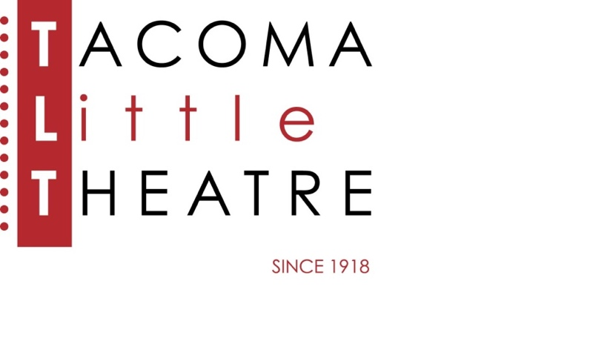

Press Release

210 North I Street, Tacoma, WA 98403    **253-272-2281**    [www.tacomalittletheatre.com](http://www.tacomalittletheatre.com)

For more information please contact:

**Chris Serface, Managing Artistic Director**

[tlt@tacomalittletheatre.com](mailto:tlt@tacomalittletheatre.com)

**FOR IMMEDIATE RELEASE** End Date: **October 24, 2024**

**AUDITIONS: THE CURIOUS INCIDENT OF THE DOG IN THE NIGHT-TIME  
OCTOBER 20-23, 2024**

*Tacoma, WA*-Tacoma Little Theatre is holding auditions for *The Curious Incident of the Dog in the Night-Time,* based on the novel by Mark Haddon and adapted by Simon Stephens. This production will be directed by Suzy Willhoft.

Auditions will be held Sunday, October 20th and Monday, October 21st at Tacoma Little Theatre (210 N I Street, Tacoma WA 98403), and Tuesday, October 22nd at the Star Center (3873 S 66th St, Tacoma, WA 98409). Audition appointments will be set starting at 6:00pm on Sunday and 7:00pm on Monday and Tuesday. Callbacks will be held on Wednesday, October 23rd at Tacoma Little Theatre. All actors must schedule their appointment using Casting Manager at the link below.

15-year-old Christopher has an extraordinary brain: He is exceptional at mathematics but ill-equipped to interpret everyday life. He has never ventured alone beyond the end of his road, he detests being touched, and he distrusts strangers. Now it is seven minutes after midnight, and Christopher stands beside his neighbor’s dead dog, Wellington, who has been speared with a garden fork. Finding himself under suspicion, Christopher is determined to solve the mystery of who murdered Wellington, and he carefully records each fact of the crime. But his detective work takes him on a thrilling journey that upturns his world.

***Anyone and Everyone is invited to audition for any production at Tacoma Little Theatre regardless of any physical attribute, gender, race, age, ability, body type, ethnicity, expressions, or experience.  All roles for this production are available to all. Anyone and everyone (minimum 16 years) is welcome! We hope to build a diverse cast and include the neurodivergent community, especially in the role of Christopher.***

Auditioners are asked to prepare a one-minute monologue. No accents please. Auditions will also include a cold read (material provided) and some movement.

All actors cast receive a travel reimbursement up to $150.00.

To reserve an audition time, follow this link (<http://castingmanager.com/audition/info/EQR6DpoNjUBcJPP>) or call our Box Office for assistance at (253) 272-2281.

Once cast, *The Curious Incident of the Dog in the Night-Time* will begin rehearsals in November of 2024. There will be a break in December for the Winter holidays. The production will run from Friday, January 24th, 2025, to Sunday, February 9th, 2025 for a total of 10 performances.

**###**