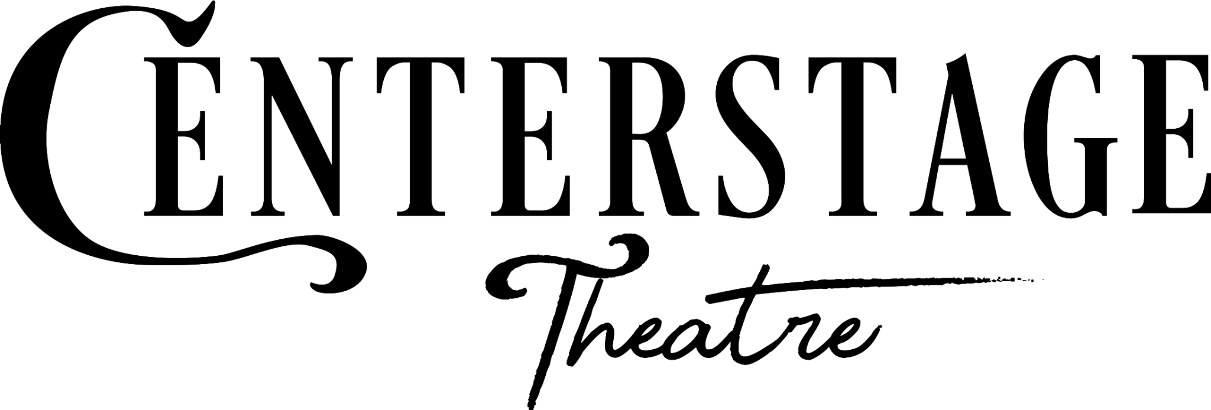

PRESS RELEASE

FOR IMMEDIATE RELEASE: January 2, 2025

**Contact:** Rylie Latham; (253) 661-1444; rylie@centerstagetheare.com

**More Info & Tickets:** www.CenterstageTheatre.com

# Centerstage is back with their traditional holiday Panto, *Miss Holmes!*

# *Written by Christopher M. Walsh*

# *Directed by Angela Bayler*

# January 31 – February 23, 2025

# Fridays and Saturdays at 7:30pm, and Sundays at 2:00pm

**FEDERAL WAY, WA**— Join Holmes and Watson on the foggy streets of London as they track a killer whose list of victims seems to be growing, even as the authorities seem unable – or unwilling – to intervene. This twisty, intriguing mystery takes the most iconic detective pairing in literary history and delivers everything you want in a mystery while turning one thing on its head: what if Sherlock and Dr. Watson were women?

**Rating:** *Recommended for ages 12 and up due to murder mystery mayhem!*

This production features local actors **Trista Duval** as Miss Sherlock Holmes, **Atlas Peek** as Dr. Dorothy Watson, **Varun Kainth** as Mycroft Holmes, **Sally Brady** as Eudora Featherstone, **Ben Stahl** as Reginald Featherstone, **Amy Anderson** as Mrs. Hudson/Dr. Anderson, **Sascha Latham** as Edwin Greener/Superintendent, **Tim Takechi** as Inspector Lestrade, **Lesley Gordon** as Lizzie Chapman, **Mathaeus Andersen** as Thomas Chapman, **Van Lang Pham** as Michael Stamford, **Nathan Cardenas** as Orderlies/Understudy, and **Christina Ramirez** as Peggy/Martha.

*Miss Holmes,* is written by the incredible playwright, **Christopher M. Walsh,** and is directed by, Centerstage’s Managing Director, **Angela Bayler. Niclas Olson** is the tech director and set designer, **Jacob Viramontes** is the lighting designer, costumes by **Morgan Morgans**, props by **Jeffrey Swiney-Weaver**, set dressing is done by **Jeff Wallace Jr**, and sound by **Chelsea** “**Mo” Moniz. Chelsea** “**Mo” Moniz** also serves as stage manager, with **Ashlyn Bogais** as assistant stage manager.

The Knutzen Family Theater is located at 3200 SW Dash Point Rd, Federal Way, WA. General Admission Tickets are $39 in advance (online or over the phone) and $41 at the door. Student, Military and Senior Ticket discounts are available. More details available online at [www.CenterstageTheatre.com](http://www.centerstagetheatre.com/) or by phone at (253) 661-1444.

**About Centerstage Theatre**

Centerstage Theatre has served as a South Sound Arts community feature since 1977, and performed inside the Knutzen Family Theatre on beautiful Dumas Bay since 1998. We employ locally-based professional and semi-professional cast and crew members and believe that theater serves to make change, build community, and expand our collective knowledge base. Centerstage Theatre is committed to enhancing the lives of Western Washington community members by presenting a family-friendly holiday panto each season as well as a full season of theatrical favorites and cutting edge new works. More at [www.centerstagetheatre.com](http://www.centerstagetheatre.com/)

# # # #

Centerstage Theatre gratefully acknowledges the support of 4Culture, Washington State Department of Commerce, The Federal Way Mirror, ArtsWA, The City of Federal Way Arts Commission, and ArtsFund.