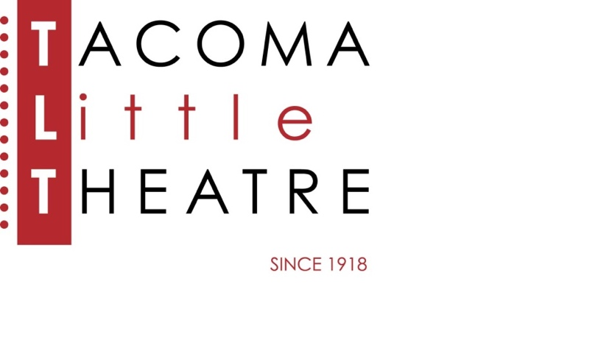

Press Release

210 North I Street, Tacoma, WA 98403    **253-272-2281**    [www.tacomalittletheatre.com](http://www.tacomalittletheatre.com)

For more information please contact:

**Chris Serface, Managing Artistic Director**

[tlt@tacomalittletheatre.com](mailto:tlt@tacomalittletheatre.com)

**FOR IMMEDIATE RELEASE** End Date: **February 6, 2025**

**AUDITIONS: BUG  
FEBRUARY 2-5, 2025**

*Tacoma, WA*-Tacoma Little Theatre is holding auditions for Tracy Letts’ disturbing thriller, *Bug*. This production will be directed by Blake R. York.

Auditions will be held on Sunday, February 2nd and Monday, February 3rd at Tacoma Little Theatre (210 N I Street, Tacoma WA 98403), and Tuesday, February 4th at the Star Center (3873 S 66th St, Tacoma, WA 98409). Audition appointments will be set starting at 6:00pm on Sunday and 7:00pm on Monday and Tuesday. Callbacks will be held on Wednesday, February 5th at Tacoma Little Theatre. All actors must schedule their appointment using Casting Manager at the link below.

The play centers on the meeting between Agnes, a lonely divorcee, and Peter, a soft-spoken Gulf War drifter. Agnes stays at a seedy motel in hopes of avoiding her abusive ex-husband, Jerry. At first, she lets Peter sleep platonically on her floor, but not long after he is promoted to the bed. Matters become more complicated as Jerry eagerly returns expecting to resume their relationship. On top of that, there’s a hidden bug infestation that has both Agnes and Peter dealing with scathing welts and festering sores—which has Peter believing this is the result of experiments conducted on him during his stay at an Army hospital. Their fears soon escalate to paranoia, conspiracy theories and twisted psychological motives.

***Anyone and Everyone is invited to audition for any production at Tacoma Little Theatre regardless of any physical attribute, gender, race, age, ability, body type, ethnicity, expressions, or experience.  Due to the adult content of this production, all auditioners must be over the age of 18. All roles for this production are available.***

***PLEASE NOTE THIS SHOW CONTAINS: Profanity, Smoking, Drinking, Heavy Drug Use (Powder Cocaine, Crack Cocaine), Physical Violence, Domestic Violence, Death, Partial Nudity, Full Nudity, On-Stage Kissing, Simulated Sex. An Intimacy Coordinator will be involved with this production.***

Auditioners are asked to prepare a one-to-two-minute dramatic monologue.

All actors cast receive a travel reimbursement up to $150.00.

Once cast, *Bug* will begin rehearsals in March of 2025. The production will run from Friday, April 25th, 2025, to Sunday, May 11, 2025, for a total of 10 performances.

To reserve an audition time, follow this link (<http://castingmanager.com/audition/info/LIQ8WFeBUCnIo77>) or call our Box Office for assistance at (253) 272-2281.

**###**