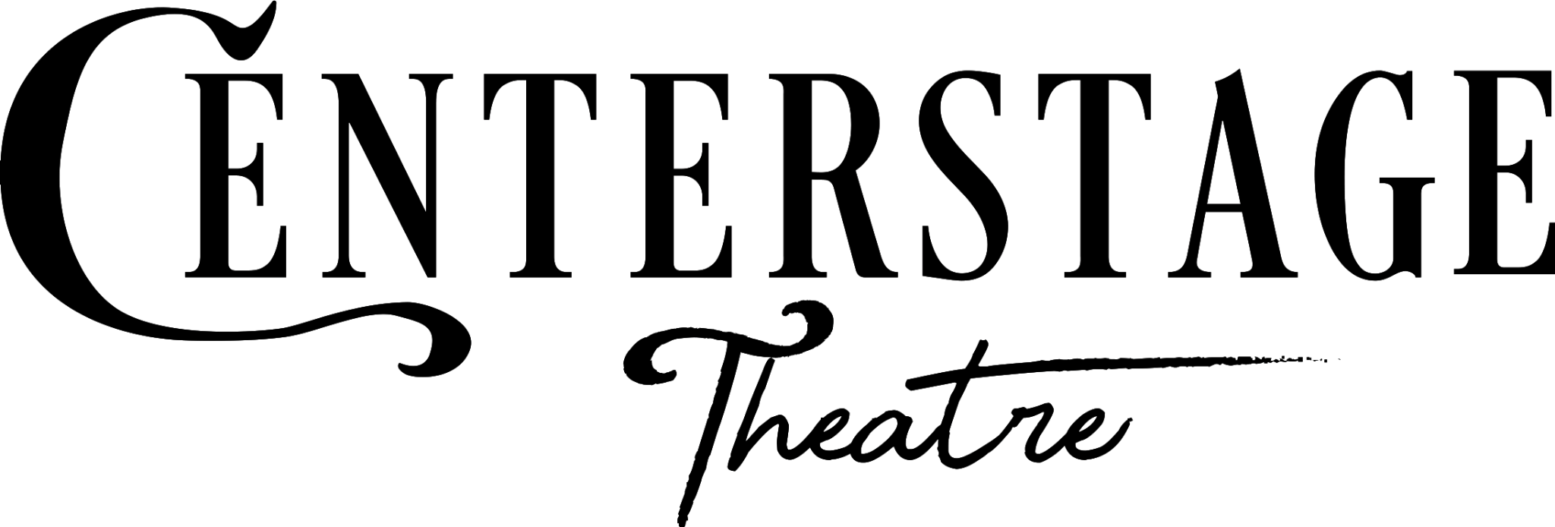
PRESS RELEASE
FOR IMMEDIATE RELEASE: January 10, 2026

Contact: Rylie Latham; (253) 661-1444; rylie@centerstagetheare.com
More Info & Tickets: www.CenterstageTheatre.com

The perfect crime begins when no one can leave.

Centerstage Presents

And Then There Were None

By Agatha Christie

Directed by Niclas Olson

January 30 - February 22, 2026

Fridays and Saturdays at 7:30pm, and Sundays at 2:00pm

FEDERAL WAY, WA—Ten strangers are summoned to a remote island. None of them know each other, all of them have a dangerous past they need to keep secret, and each of them are now in the carefully laid trap of a murderer. As a storm rages outside, the group becomes completely cut off from the outside world, and the killings begin…one by one, the guests are murdered; the only connecting thread being the lines of a sinister nursery rhyme. What is the motive of their executioner, and will there even be anyone left to tell the tale?

Rating: Suggested ages 13+ for murderous mayhem

This production features local actors Varun Kainth as Philip Lombard, Juliette Jones as Vera Claythorne, Amy Anderson as Mrs. Rogers, Scott Pinkston as Mr. Rogers, Tess Jenkins as Emily Brent, Peter Cook as Lawrence Wargrave, Vince Brady as William Blore, Dale Bowers as Justice Mackenzie, Van Lang Pham as Edward Armstrong, Jake Nix as Narracott, and Anden J. Leo as Marston.

And Then There Were None is written by the incomparable Agatha Christie, and is directed by Niclas Olson, who is the tech director and set designer as well. Elizabeth Bonar is the lighting designer, Krista Lofgren is the costumer, props are by Jeffery Swiner-Weaver, Chelsea “Mo” Moniz is the sound designer, Tori Dewar is the scenic painter, stage manager is Dean Marshall with Natalie Clark as assistant stage manager, and Phoebe Bumbury is a stagehand.

The Knutzen Family Theater is located at 3200 SW Dash Point Rd, Federal Way, WA. General Admission Tickets are $40 in advance (online or over the phone) and $43 at the door. Group, Student, Military and Senior Ticket discounts are available. More details available online at www.CenterstageTheatre.com or by phone at (253) 661-1444.

Pay What You Will performance is on Saturday, January 31 at 7:30pm

About Centerstage Theatre
Centerstage Theatre has served as a South Sound Arts community feature since 1977, and performed inside the Knutzen Family Theatre on beautiful Dumas Bay since 1998. We employ locally-based professional and semi-professional cast and crew members and believe that theater serves to make change, build community, and expand our collective knowledge base. Centerstage Theatre is committed to enhancing the lives of Western Washington community members by presenting a family-friendly holiday panto each season as well as a full season of theatrical favorites and cutting edge new works. More at www.centerstagetheatre.com

Rylie Latham Hubbard
Marketing Manager & Administration
Centerstage Theatre
rylie@centerstagetheatre.com
(253) 661-1444
https://centerstagetheatre.com/

# # # #

Centerstage Theatre gratefully acknowledges the support of 4Culture, Washington State Department of Commerce, The Federal Way Mirror, ArtsWA, The City of Federal Way Arts Commission, and ArtsFund.

