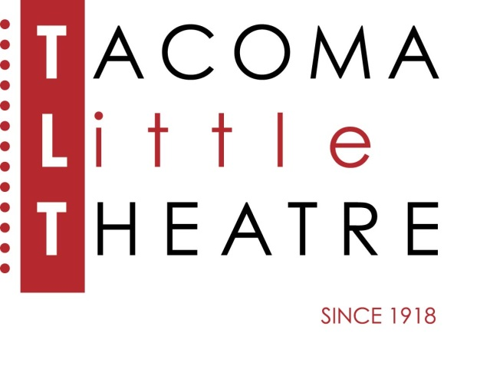
Press Release
210 North I Street, Tacoma, WA 98403 253-272-2281 www.tacomalittletheatre.com
For more information please contact:
Chris Serface, Managing Artistic Director
tlt@tacomalittletheatre.com

FOR IMMEDIATE RELEASE End Date: February 9, 2026
TACOMA LITTLE THEATRE PRESENTS
REVENGE AT THE REUNION-A MURDER MYSTERY DINNER

Tacoma, WA- Tacoma Little Theatre is back with another Murder Mystery Dinner for the New Year, REVENGE AT THE REUNION, by Paula Hilton and directed by Micheal O’Hara.
REVENGE AT THE REUNION will run February 5-8, 2026. Thursday-Saturday performances will begin at 7:00pm, and the Sunday performance will begin at 12:00pm. The production will take place at The LaQuinta Inn & Suites, 1425 E 27th Street, Tacoma, Washington, 98421. RESERVATIONS ARE REQUIRED.

In high school, they called themselves the Forever Five. "Five best friends forever." Or so they said. But by the end of their senior year, they were barely on speaking terms and went their separate ways without looking back.
So what will happen when the Forever Five reunite at this year's class reunion?
Featuring: Jordyn Konopaski as Sugar Codit, Christina Ramirez as Valerie Hughes, Jacob Vallie as Hugh Topian, Stephanie Wade as Bea Wangled, and Charlie Stevens as Cole Lappsed.

Will they let bygones be bygones? Will they let all those old misunderstandings be water under the bridge? Chalk it up to silly youth? Maybe. But you better stay on your toes at this class reunion because someone may decide that to forgive and forget is for the birds and go instead for revenge.

Dinner includes:
-APPETIZER BUFFET- Assorted items for before the mystery starts
-PLATED SALAD- Assorted greens, candied walnuts, dried cranberries, and bleu cheese with a balsamic vinaigrette.
-YOUR CHOICE OF MAIN ENTREE-(Lactose free and gluten free options are available)
Chicken Dijon with Roasted Potatoes, Vegetable Medley, rolls, and butter.
-OR- Vegetarian Pasta Primavera with Creamy Garlic Sauce and assorted vegetables.
-DESSERT-
Coffee, Tea, and Water are included. Other beverages including alcohol are available for purchase at the bar.

Tickets are $80.00 per person (includes dinner, gratuity, and show) and may be purchased online at www.tacomalittletheatre.com, or by calling our Box Office at (253) 272-2281.

###

